ta****

Capstone Project Phase B

Project No. 24-1-D-33

**Sports club management**

Supervisor: Prof. Zeev Barzily

|  |  |  |
| --- | --- | --- |
| Name | ID | Email |
| Ahmed Mahamid | 315038208 | [Ahmed.Mahamid@e.braude.ac.il](mailto:Ahmed.Mahamid@e.braude.ac.il) |

Table of Contents

1 Introduction 6

2 Who the stakeholders are and how the solution will help them: 7

3 Background and Related Work 8

3.1 Related work 8

3.2 Survey 8

3.3 Web Platform Development: 9

3.4 Client-Server Model 10

3.5 PHP 11

3.6 Laravel 11

3.7 MySQL 11

4 Expected Achievements 12

4.1 Project Goals 12

4.2 Unique Features 12

4.3 Project Expectations 12

4.4 Success Criteria 13

5 Engineering process 14

5.1 Process 14

5.1.1 Requirement Gathering and Analysis: 14

5.1.2 Iterative Development Approach: 14

5.1.3 The iterative process involves the following steps: 14

5.1.4 Constraints and Considerations: 15

6 Challenges and Solutions 16

7 Product 17

7.1 diagrams 17

7.1.1 Software Architecture Diagram: 17

7.1.2 flowchart: 18

7.1.3 Use-Case Diagram: 18

7.1.4 Class Diagram: 19

7.1.5 Package Diagram: 19

7.1.6 Deployment Diagram: 20

8 User guide 20

8.1 Guest User Experience 20

8.1.1 Login Screen: 21

8.1.2 Registration screen/join now: 22

8.1.3 Homepage Overview 23

8.1.4 About Us 23

8.1.5 Course Listings 24

8.1.6 Latest Blog Feed 25

8.1.7 Client Reviews 27

8.1.8 BMI Calculator 27

8.1.9 Footer Section 28

8.2 Member Experience 29

8.2.1 Post-Login Interface 29

8.2.2 Course Registration 29

Registration Outcomes: 30

8.2.3 Personal Dashboard 31

Profile: 32

8.2.4 My Courses: 32

8.2.5 Send Message to Trainer : 33

8.2.6 Notifications 34

8.2.7 Messages 35

8.3 Instructor Experience 35

8.3.1 Personal Information 35

8.3.2 Course Management 36

8.3.3 Communication Tools 37

8.4 Admin Experience 38

8.4.1 Admin Dashboard 38

8.4.2 Specializations: 40

8.4.3 Courses 40

8.4.4 Members 42

8.4.5 Reviews 45

8.4.6 Instructors/Trainers 46

8.4.7 Halls 48

8.4.8 Equipment 49

Equipment Management: 49

8.4.9 Pages 50

8.4.10 Posts 50

8.4.11 Slideshows: 51

8.4.12 Users 52

8.4.13 Settings 53

8.4.14 Payment 54

8.4.15 Notes 55

9 Maintenance Guide 56

9.1 Technology Summary: 56

9.2 Technical Details: 56

9.3 Applying the Technologies in the Project: 57

9.4 Project Development Environment Requirements: 58

9.5 running the Sports Club Project on Another Device: 60

10 .Tests: 62

10.1 Unit Tests: 62

10.1.1 Registration 62

10.1.2 Login: 63

10.1.3 Course Registration: 63

10.1.4 Course Creation (Admin): 64

10.1.5 Messaging System: 64

10.2 Manual testing 65

11 . Results & Conclusion: 66

12 . References 67

Abstract

The project focuses on developing a sports club management system aimed at streamlining course management and communication between participants and instructors. The system is built using PHP (Laravel) on the backend, with MySQL managing the database. On the frontend, HTML, CSS (Bootstrap), and JavaScript (jQuery and Axios) are used to enhance the user experience and ensure responsiveness across all devices.

The system includes an administration interface for instructors and managers, allowing them to track and manage courses, oversee club members, create schedules, and update course information. Instructors can update lesson details and communicate with participants, while participants can register for courses, view schedules, and send messages to instructors.

The project integrates advanced modules like DataTables, which enable efficient data management with sorting, filtering, and advanced search features. Additionally, Blade Templating Engine is used to create dynamic interfaces that merge server-side content with personalized views.

The main challenge in this project was creating a system that caters to both managers and users while maintaining data security and scalability for multiple users. Another challenge was integrating the different interfaces and managing real-time communication between users and the system.

This project significantly improves the user and management experience for sports clubs by providing a unified platform that consolidates all necessary functions in one place, enhancing and streamlining both administration and user participation.

# Introduction

In today's fast-paced world, sports clubs play a crucial role in promoting physical activity, fostering a sense of community, and providing a platform for personal growth and development. However, managing the intricate operations of a sports club can be a daunting task, often plagued by inefficiencies and manual processes. This is where our innovative sports club management system comes into play, offering a comprehensive and user-friendly solution to streamline operations and enhance the overall experience for members, instructors, and administrators alike.

The system aims to address the challenges faced by traditional sports club management approaches, and difficulties in managing course schedules, instructor availability, and member registrations using manual processes, leading to inefficiencies and potential conflicts.

The system leverages modern technologies and incorporates feedback from stakeholders to create a platform tailored to the unique requirements of sports clubs. By integrating features such as course administration, facility management, reservation systems, and financial management, I aim to streamline operations and enhance efficiency across all aspects of the club's operations.

For members, the system offers a user-friendly interface that allows them to easily browse and register for courses, view their training progress, schedule sessions with instructors, and provide feedback through opinion reports. Additionally, members can receive timely notifications and updates, ensuring they stay informed about important an announcements and events.

Instructors benefit from dedicated tools that enable them to manage their schedules, specialties, and course details with ease. This not only enhances their productivity but also ensures that members receive high-quality instruction and a consistent experience.

Administrators and managers gain access to powerful tools for managing users, instructors, facilities, and courses. They can efficiently handle tasks such as adding, editing, and removing users, instructors, and courses, as well as managing hall availability and bookings. Furthermore, the system provides valuable insights and data for informed decision-making and strategic planning.

By addressing the limitations of existing solutions and incorporating best practices from related research, my sports club management system aims to revolutionize the way sports clubs operate, fostering a seamless and engaging experience for all stakeholders.

# Who the stakeholders are and how the solution will help them:

* Members:

Interest: Enjoy seamless access to manage all your sports activities at the club. The platform provides a personalized experience to track progress, stay updated on events, and easily register for courses aligned with your fitness goals.

Efficiency: Quickly access detailed course information, schedules, and progress tracking. Join new classes, monitor achievements, and stay engaged with the club community in just a few clicks.

* Instructors:

Interest: Benefit from advanced tools that enhance daily management and improve instruction quality. Easily access student progress reports, attendance, and course materials, allowing you to focus more on teaching.

Efficiency: Effortlessly manage courses with automated scheduling, direct communication with members, and real-time feedback, fostering a dynamic learning environment.

* Managers/Administrators:

Interest: Experience enhanced oversight and management of club operations. The platform provides clear visibility into all activities, ensuring that details are accessible and well-maintained for better decision-making.

Efficiency: Streamline operations with powerful tools for schedule management, member engagement tracking, and strategic data access, driving the club's success through informed decisions.

* Guests:

Access: Browse the club’s website to explore course descriptions, instructor biographies, and the latest news. Get familiar with our offerings before committing.

Requirement for Course Registration: To register for courses, guests must create an account and become members, unlocking full access to all club benefits, including personalized recommendations and progress tracking.

# Background and Related Work

## Related work

During the research phase of this project, I explored existing systems to find a solution that integrates both management and member functionalities into a single platform. However, I found that most existing systems tend to focus on only one side of the club's operations. Some platforms offer a backend interface exclusively for managers and staff to handle administrative tasks, such as scheduling and member management. These systems lack any interface or functionality for club members to engage with the club's offerings.

On the other hand, the platforms designed for club members often provide a limited view, allowing them only to browse available courses without the ability to register directly through the website. Many of these platforms also fail to offer features for tracking enrolled courses or communicating directly with instructors.

In contrast, the system I developed represents a significant improvement over existing solutions. My platform offers two distinct interfaces—one for managers and staff, and another for club members. This dual-interface approach ensures that all stakeholders have the tools they need within one unified system. Members can easily register for courses online, track their progress, manage their enrolled courses, and communicate directly with their instructors. Instructors, in turn, can update trainees and manage course materials effortlessly.

By integrating these functionalities into a single platform, my system not only enhances existing features but also introduces new, essential capabilities that were previously missing. This comprehensive approach aims to provide a perfect solution that meets the needs of both the club's management and its members, thereby offering a more complete and effective online experience.

## Survey

To kick off the project, I conducted a comprehensive survey with 15 sports club managers to gain insights into their operational challenges and to gather detailed requirements for a new management system. The results were revealing:

80% of the managers expressed dissatisfaction with their current systems, primarily due to inefficiencies in course administration and difficulty in managing instructor schedules.

70% highlighted the lack of integration between member registration and course tracking, which has led to increased manual work and errors.

50% reported that their current systems do not offer adequate analytics or reporting tools, making it challenging to make informed decisions.

40% mentioned problems with facility management and scheduling conflicts, which often result in overbooking or underutilization of club resources.

40% noted issues with payment processing and tracking, leading to delayed or missed payments from members.

During these meetings, I asked managers about their daily challenges

The type of reporting or analytics that would aid in their decision-making.

Based on their responses, I meticulously documented both functional and non-functional requirements, prioritizing them according to their importance and impact on the overall system. This survey has laid a solid foundation for developing a robust and user-friendly management platform that addresses the specific needs of sports clubs.

## Web Platform Development:

I chose to develop our project as a web platform for several key reasons:

Accessibility: A web platform offers universal access across different devices, ensuring that both members and managers can interact with the system from any location without needing to download or install an application. This ease of access is crucial for a sports club environment where users may need to quickly check schedules, register for courses, or manage operations on the go.

User Engagement: The platform is designed to enhance communication between members, instructors, and managers. Features like direct messaging, real-time notifications, and announcements are integrated seamlessly into the web interface, ensuring timely updates and fostering an active community within the club.

Multi-User Interface: The web platform allows for the development of distinct interfaces tailored for different types of users—members, instructors, and managers. This ensures that each group has access to the tools and information most relevant to their roles, improving overall efficiency and satisfaction.

Scalability and Integration: A web-based solution can easily integrate with existing systems and expand as the club grows. Whether it's adding new features, incorporating third-party tools, or scaling up to accommodate more users, the flexibility of a web platform ensures long-term sustainability and adaptability.

Centralized Data Management: With all data stored and managed on a centralized web server, it becomes easier to maintain, update, and secure the information. Managers have quick access to analytics and reports, aiding in informed decision-making and efficient management of club resources.

This approach ensures that our solution not only meets the immediate needs of the sports club but also provides a scalable, user-friendly platform that can evolve with the club's future demands.

## Client-Server Model

For our sports club management platform, a robust client-server model is essential due to the need for continuous access to a large and dynamic dataset. This includes member information, course schedules, instructor details, and real-time updates. The client-server architecture ensures that all users—whether they are members, instructors, or managers—have reliable access to the latest data while maintaining system efficiency and security.

What is a Client-Server Model?

A client-server model is a network architecture where multiple client devices (such as computers, tablets, or smartphones) communicate with a central server to request services and access data. The server is responsible for handling these requests and delivering the necessary resources back to the clients. This architecture is fundamental in web-based systems where centralized data management is crucial.

The client-server model operates on the following principles:

Client Programs: These are application programs running on local devices (e.g., a member’s smartphone or a manager’s computer) that request services from the server. For instance, when a member logs in to view their course schedule, the client program sends a request to the server to retrieve this information.

Server Programs: These are application programs running on a central server that constantly awaits client requests. The server processes each request, retrieves the necessary data, and sends it back to the client. The server always remains active to handle requests from multiple clients simultaneously.

Many-to-One Relationship: The client-server model follows a many-to-one relationship, meaning one server can handle requests from multiple clients at the same time. This is particularly useful in our platform, where numerous members and staff may access the system concurrently, each requiring different data or services.

This architecture is chosen for its ability to efficiently manage multiple users, secure data storage, and provide a seamless experience across various devices. The client-server model is vital for ensuring that all components of the sports club management system work harmoniously, offering a reliable and scalable solution for both current and future needs.

## PHP

PHP (Hypertext Preprocessor) is a widely used, open-source scripting language ideal for web development. Known for its ease of use, speed, and ability to handle dynamic content, PHP is executed on the server, delivering results as HTML to the browser. With 76.2% of websites utilizing PHP [1], it’s a top choice for creating dynamic and interactive web applications, making it well-suited for developing a robust sports club management system.

## Laravel

Laravel is a popular PHP framework that simplifies web development with tools for tasks like authentication, routing, and caching. Its elegant syntax and ability to handle complex applications securely have made it the preferred choice for 61% of PHP developers [2]. Laravel’s built-in libraries and tools, such as database migrations and ORM, streamline the development process, making it efficient and developer friendly.

## MySQL

MySQL is an open-source relational database management system (RDBMS) known for its reliability and performance. It pairs seamlessly with PHP, providing a solid foundation for building dynamic, data-driven web applications. As the second most popular database system [3], MySQL’s robustness and ease of use make it the ideal choice for managing data in a sports club management system.

These technologies PHP, Laravel, and MySQL combine to create a scalable, efficient, and user-friendly platform, ideal for building a comprehensive sports club management system.

# Expected Achievements

## Project Goals

The primary goal of this project is to develop a comprehensive sports club management system that integrates both administrative and member-facing functionalities into a unified platform. This system aims to streamline the management of courses, instructors, and member activities while enhancing user engagement and satisfaction. The platform will provide a seamless experience for all stakeholders—managers, instructors, and members—by offering tools that improve efficiency, communication, and decision-making processes.

## Unique Features

Dual Interface System: The platform offers separate, tailored interfaces for managers and members, ensuring each user group has access to relevant features.

Course Registration and Management: Members can register for courses online, track their progress, and manage their enrolled courses.

Real-Time Communication: Integrated messaging allows members to communicate directly with instructors, facilitating real-time updates and feedback.

Analytics and Reporting: Managers can access comprehensive analytics and reporting tools to make informed decisions about club operations.

Scalable Architecture: The system is built with scalability in mind, allowing for future growth and the addition of new features without disrupting current operations.

## Project Expectations

The project is expected to deliver a user-friendly, efficient, and reliable management system that meets the needs of both the club’s administration and its members. The platform should reduce the administrative burden on managers, provide instructors with better tools for course management, and offer members an engaging and easy-to-use interface. Additionally, the system should be robust enough to handle the club’s current demands while being flexible enough to accommodate future growth.

## Success Criteria

The success of the project will be measured by the following criteria:

User Satisfaction: Positive feedback from managers, instructors, and members regarding the system’s usability and effectiveness.

Operational Efficiency: Demonstrated improvements in the club’s administrative processes, including faster course management and better communication with members.

User Adoption Rate: High adoption rates among all user groups, indicating that the platform meets their needs and is easy to use.

System Reliability: The platform’s ability to function smoothly under varying loads without crashes or significant downtime.

Scalability: The system’s capacity to support additional users, courses, and features as the club grows, without requiring major overhauls.

Number of different devices and browsers supported without issues

# Engineering process

## Process

As the sole developer of this sports club management system project, I have adopted an iterative and incremental approach to the engineering process. This approach allows me to break down the development into manageable phases and make necessary adjustments along the way.

### Requirement Gathering and Analysis:

To kick off the project, I met with the sports club managers to understand their pain points and gather requirements. During these meetings, I asked them about the daily challenges they face in managing the club and what they expect from a management system. Some key questions I asked included:

- What are the current processes for course administration, instructor management, and member registration?

- What are the major issues in these processes?

- What features or functionalities would you like to see in a new management system?

- How do you currently handle facility management, scheduling, and payments?

- What kind of reporting or analytics would be helpful for decision-making?

Based on their responses, I documented the functional and non-functional requirements, prioritizing them based on their importance and impact on the overall system.

### Iterative Development Approach:

To address the requirements effectively, I have adopted an iterative development approach using the Agile methodology. This approach involves breaking down the project into smaller, manageable iterations or sprints, each focusing on delivering a specific set of features or functionalities.

### The iterative process involves the following steps:

1. Planning: At the beginning of each iteration, I define the scope, prioritize the requirements, and create a detailed plan.

2. Design: Based on the requirements, I design the system architecture, database schema, and user interfaces for the features to be developed in the current iteration.

3. Development: Using PHP, Laravel, MySQL, CSS, Bootstrap/Tailwind CSS, HTML5, and JavaScript, I implement the planned features, following best practices and coding standards.

4. Testing: Throughout the development process, I conduct unit tests, integration tests, and user acceptance testing to ensure the quality and functionality of the developed features.

### Constraints and Considerations:

As a solo developer, I need to be mindful of the following constraints and considerations:

1. Time Management: Effective time management is crucial to ensure the timely finish of each iteration.

2. Resource Allocation: As the sole developer, I need to allocate my time and effort judiciously across various tasks, such as coding, testing, and documentation.

3. Scalability and Maintainability: From the outset, I need to design the system with scalability and maintainability in mind, ensuring that it can accommodate future growth and changes without significant rework.

By following this iterative and incremental engineering process, leveraging modern technologies, and considering the constraints and considerations, I aim to deliver a high-quality, user-friendly, and efficient sports club management system that meets the stakeholders' requirements.

# Challenges and Solutions

Integration of Dual Interfaces: One of the main challenges was ensuring that both the manager and member interfaces functioned seamlessly while addressing the unique needs of each user group. Initially, I faced issues where features specific to managers would overlap with member functionalities. To solve this, I adopted a modular approach, separating the interfaces and clearly defining the roles and permissions for each user type. This ensured that the platform is intuitive and tailored to both user groups without any conflicts in functionality.

Data Security and Privacy: Maintaining data security and privacy was a significant concern, especially when handling sensitive member and club data. Implementing secure authentication methods such as hashed passwords, SSL encryption, and access controls was necessary. I integrated Laravel’s built-in security features, such as CSRF protection and encrypted cookies, and further fortified the system by adding role-based access control to ensure that only authorized users can access certain information.

Scalability: As the platform was designed to accommodate a growing number of users, ensuring scalability was a challenge. Initially, performance issues arose when handling large datasets. To resolve this, I optimized the database queries and employed caching mechanisms through Laravel’s built-in caching features. I also designed the system architecture in a way that allows for easy horizontal scaling as the user base grows.

Requirement Gathering and Analysis: Gathering and analyzing requirements from various stakeholders, such as club managers and members, was a time-consuming task. To overcome this, I created a detailed survey and held multiple meetings with stakeholders. I prioritized their needs based on impact and urgency, ensuring that the system addressed the most pressing issues first, while keeping future scalability and functionality in mind.

Working Alone: Building the software alone presents another challenge. Without a partner to bounce ideas off of or provide assistance, I'm solely responsible for solving every problem that arises. This means I have to rely solely on my own thinking and creativity to tackle each issue without the input or collaboration of a partner. Additionally, the absence of a partner means there's no one to share the workload with or provide additional ideas, making the process more challenging. As a result, working alone requires me to put in extra effort and work doubly hard to ensure everything is completed on time and to a high standard.

# Product

## diagrams

### Software Architecture Diagram:

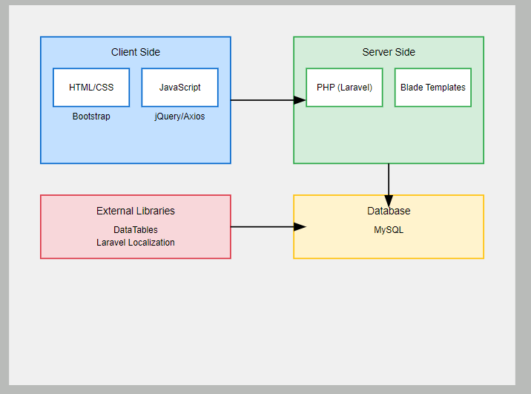

### flowchart:

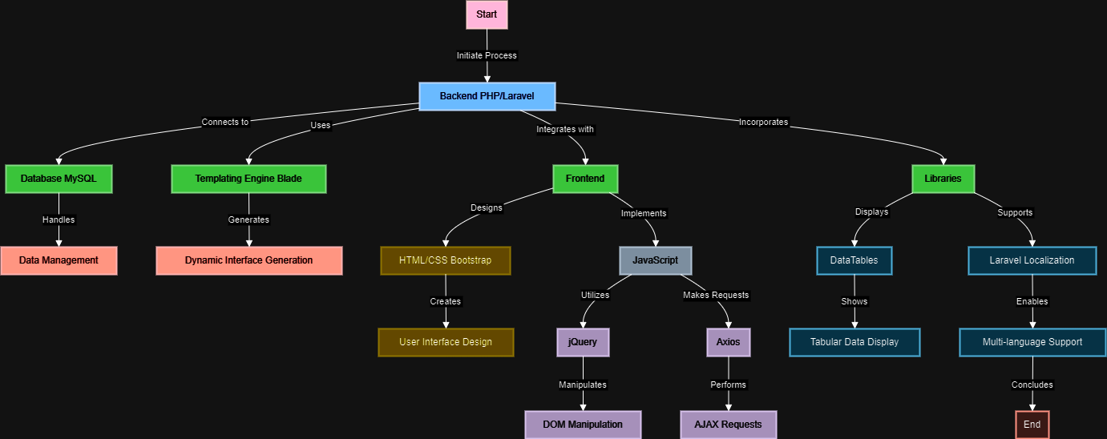

### Use-Case Diagram:

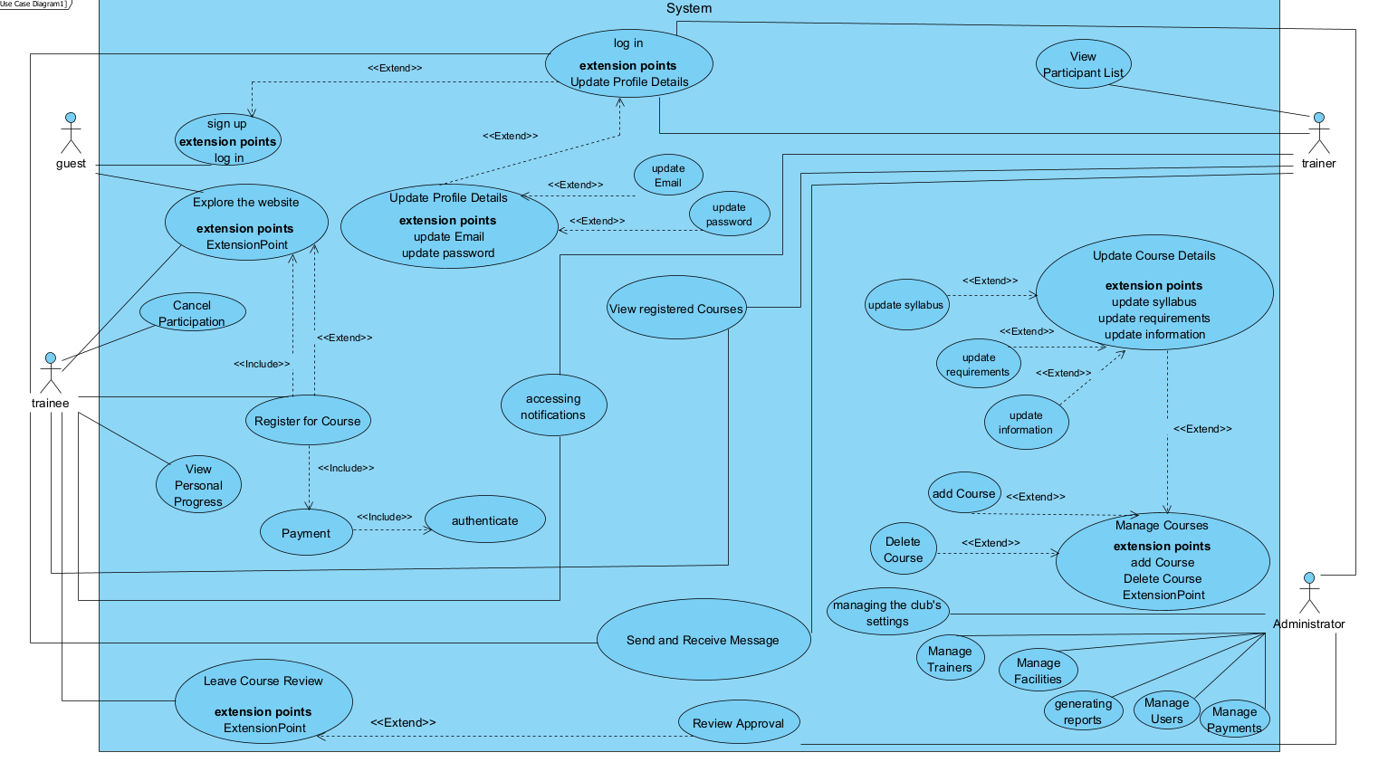

### Class Diagram:

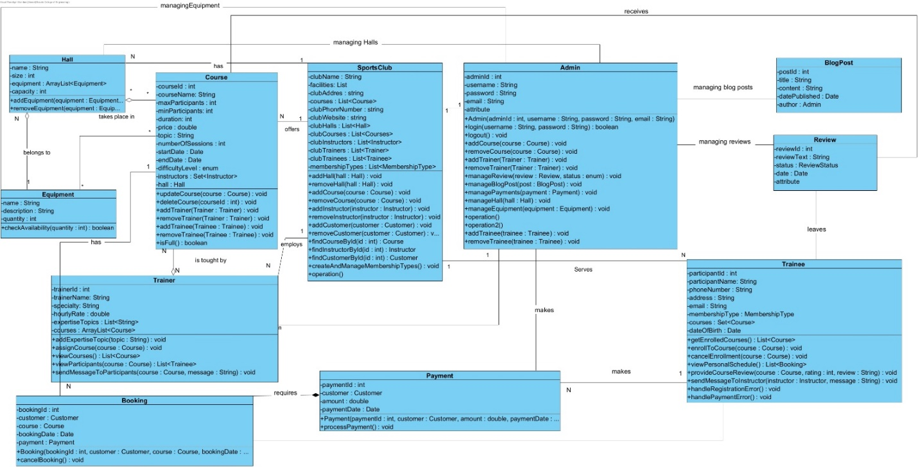

### Package Diagram:

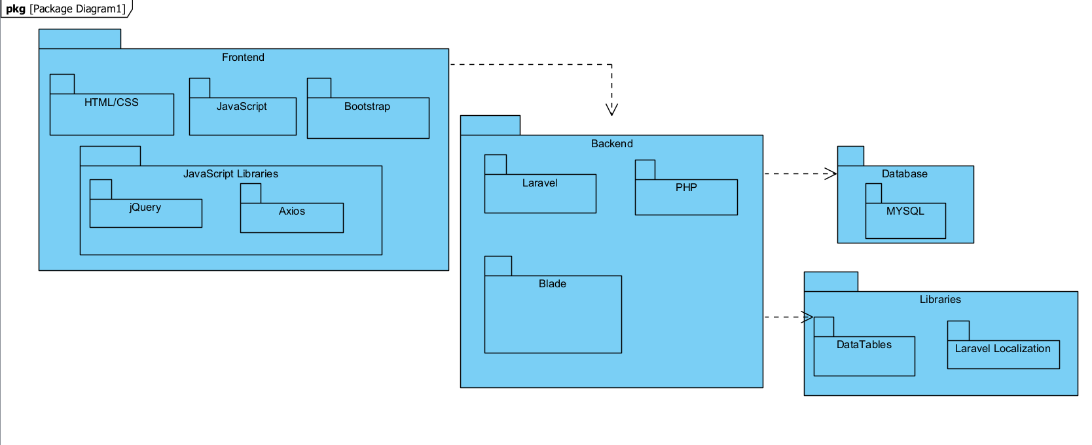

### Deployment Diagram:

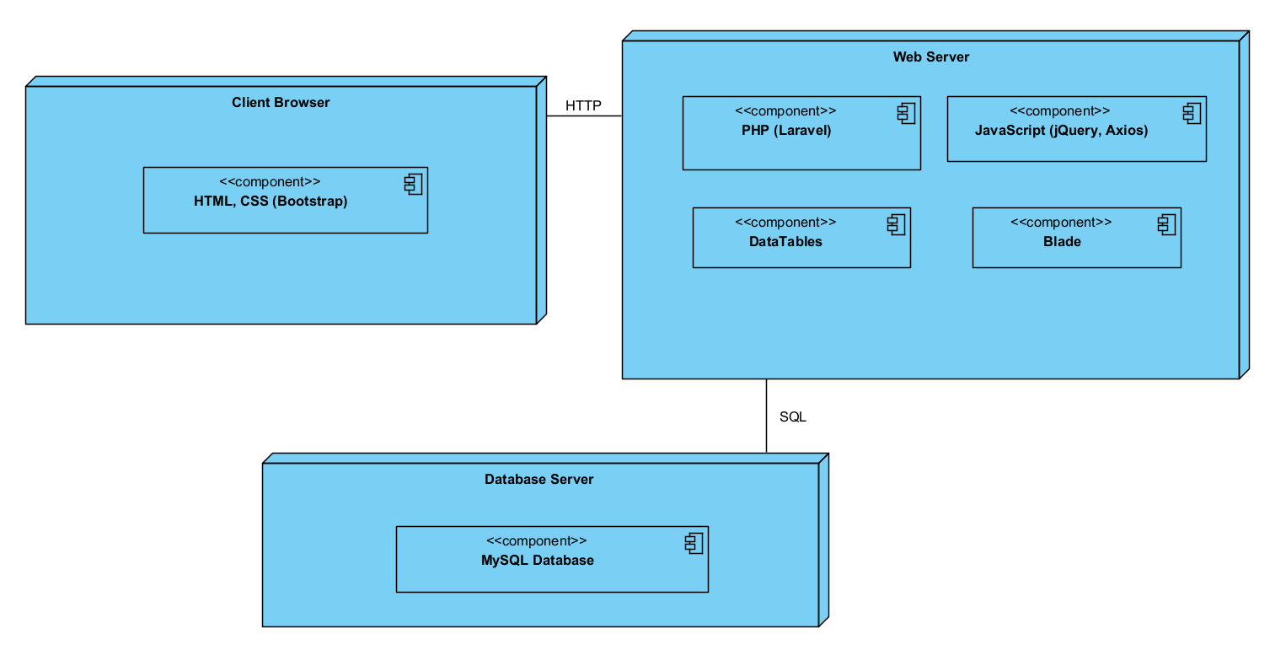

# User guide

**The user documentation provides comprehensive instructions and guidance for users of the sports club management system. This document is designed to help all user types—members, instructors, managers, and guests—understand how to effectively use the platform to meet their needs. The documentation covers the following areas:**

* **Purpose: Overview of the sports club management system and its objectives.**
* **Audience: A breakdown of who this documentation is for (members, instructors, managers, and guests).**
* **System Requirements: Information on the necessary hardware, software, and internet connectivity needed to access and use the platform.**

## Guest User Experience

**As a guest, you can explore various features of the sports club website. However, certain actions, such as course registration, require creating an account. Below is a detailed walkthrough of what a guest can do on the website:**

**1. Accessing the Website**

**The address for the Sport Club Management web application is:**

[fithub-fitness.com/en](https://fithub-fitness.com/en)

**\*\*Pay attention;** to **Session Timeout for Enhanced Security: To enhance security and protect user data, the system is designed to log users out after a predetermined period of inactivity automatically. This feature ensures that unauthorized access to a user's account is minimized in case the user leaves their device unattended. Additionally, this mechanism helps manage database resources efficiently by reducing the number of active sessions that need to be maintained.**

**This timeout feature is especially important for protecting sensitive information and maintaining the overall integrity of the system, providing both security and performance benefits.**

**When a guest visits the website, they land on the homepage, which is designed to provide a comprehensive overview of what the club offers. The upper part of the page includes the navbar with options like "Home," "About Us," "Courses," and "Blog." Additionally, you'll find the Login and Join Now buttons prominently displayed. As a guest, creating an account is necessary to access members-only features.**

### Login Screen:

1. **Enter your username in the "Username" field.**
2. **Enter your password in the "Password" field. Note that the password characters will be hidden for security purposes.**
3. **Ensure that both the username and password are entered correctly.**
4. **If you encounter any errors during the login process, such as an incorrect username or password, an error message will be displayed below the login form.**
5. **Carefully read the error message and verify your login credentials before attempting to log in again.**

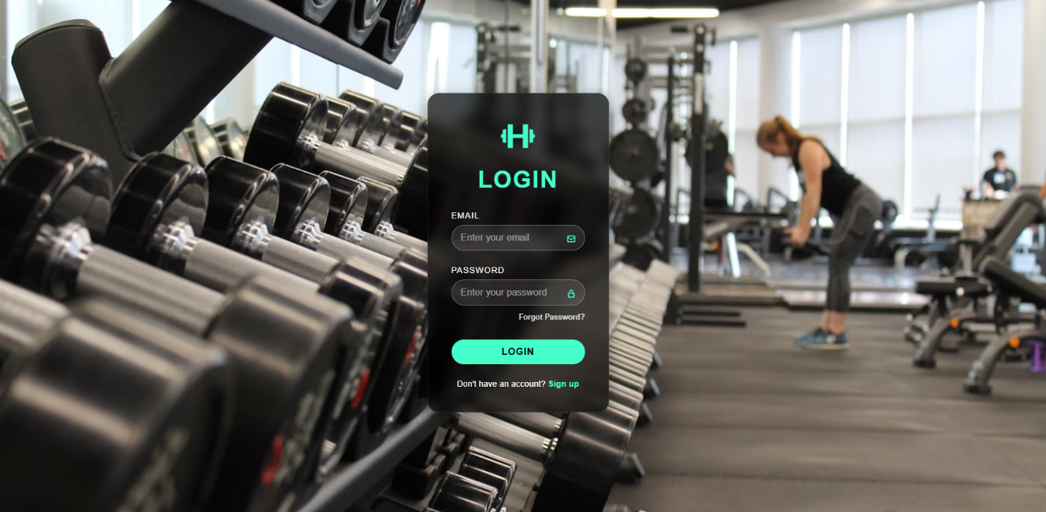

### Registration screen/join now:

1. **Enter a username that you want to use in application.**
2. **Enter the Email that you want to use in application, note that the Email is not already registered in the system.**
3. **Enter your phone number that you want to use in application.**
4. **Enter your location that you want to use in application.**
5. **Enter password of your choice.**
6. **In confirm password make sure that you enter the same password from the password field, or the registration fails, and an error will appear.**

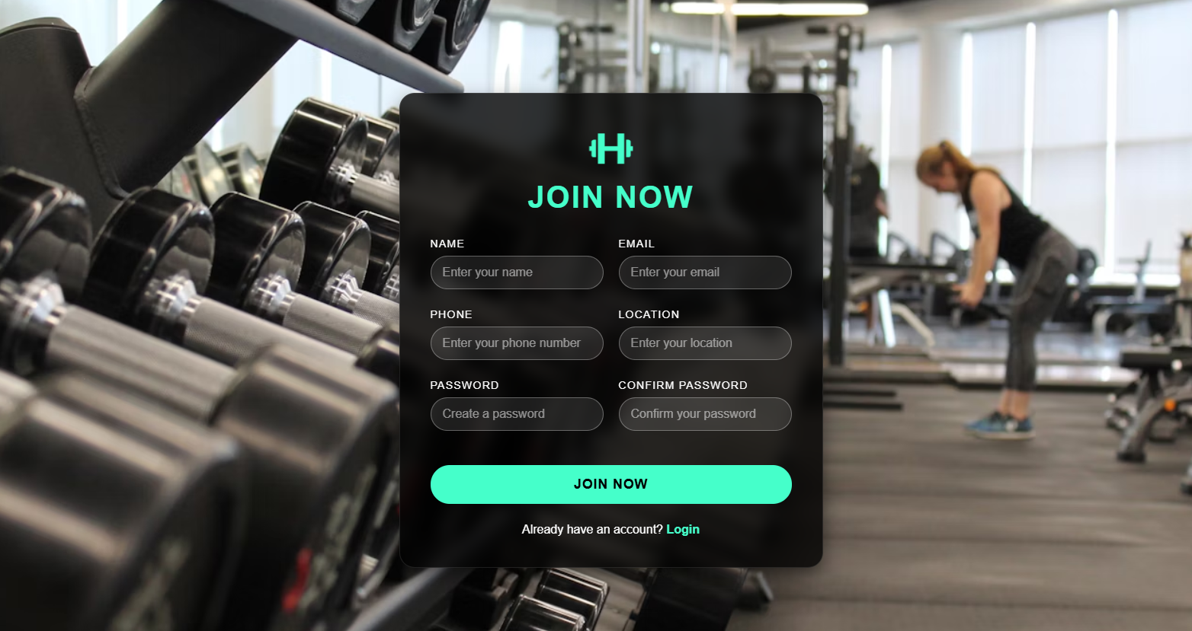

### Homepage Overview

**The homepage starts with a dynamic section where the navbar is located at the top. This section also features a hero banner that showcases rotating messages highlighting the various courses and activities offered at the club.**



### About Us

**The next section provides an overview of the club, explaining why it's the best choice for fitness enthusiasts. Here, key statistics about the club, such as the number of active members, available courses, and successful transformations, are displayed to build trust and credibility.**

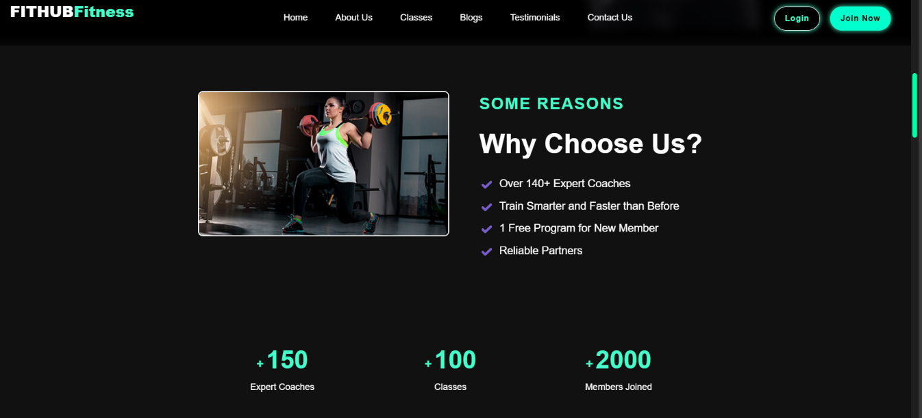

### Course Listings

**One of the most important sections for a guest is the Course Listings. This area showcases the available courses at the club, providing essential details such as the course name, a brief description, start and end dates, and the number of participants currently enrolled.**

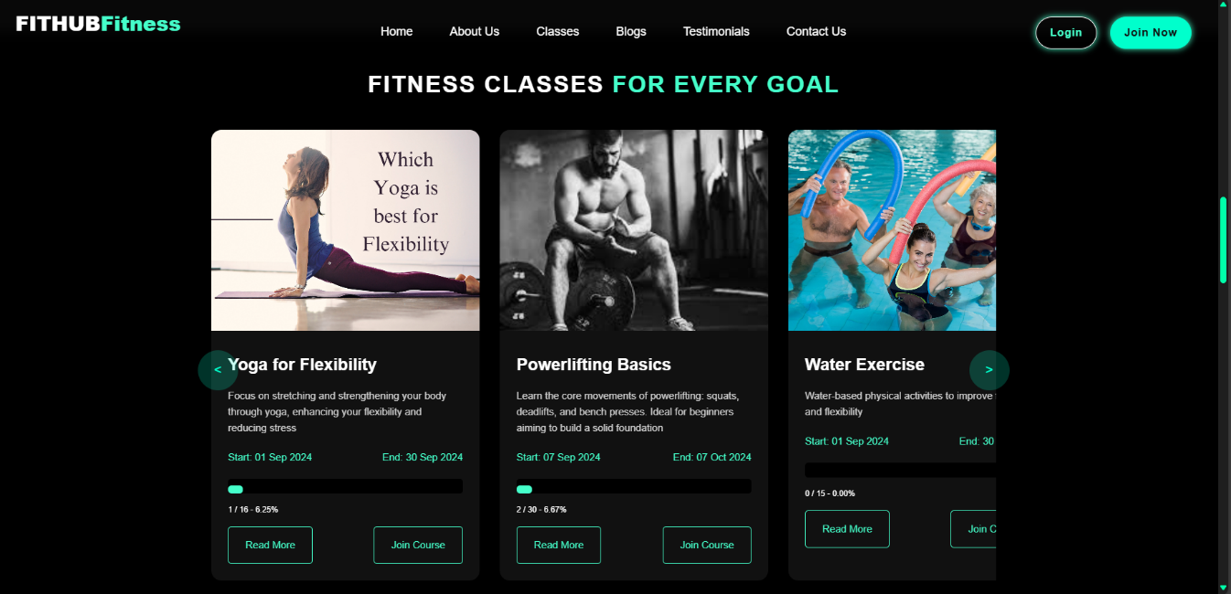

**Read More Button: Clicking on this button leads to a detailed course page. Here, guests can view an overview of the course, what they will learn, requirements, the days the course is offered, the hall name, the number of sessions, the price, and information about the instructor.**

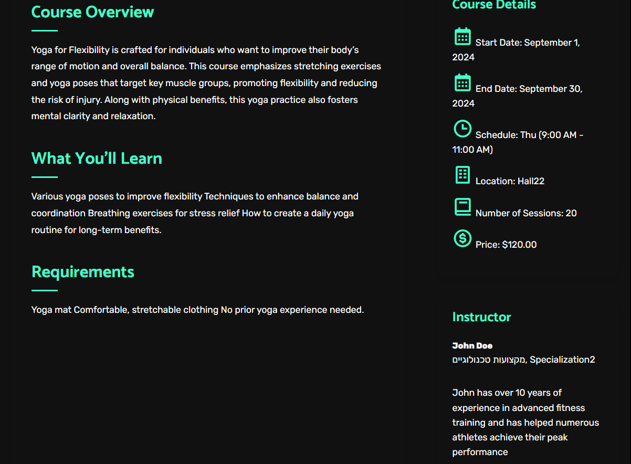

**Registration Button: If a guest tries to register for a course, they will be prompted to log in or sign up, as course registration is restricted to members only.**

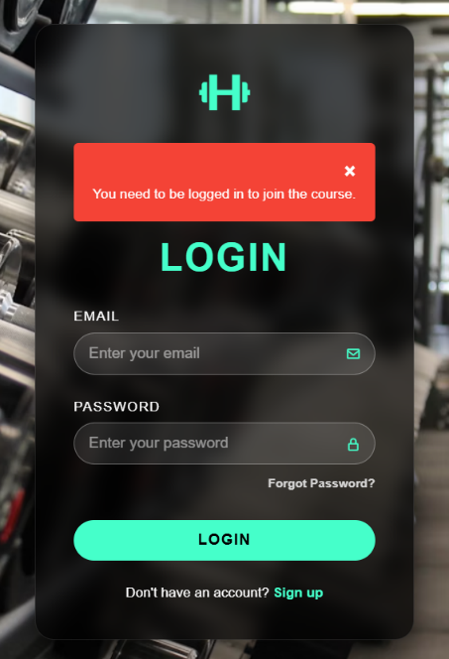

### Latest Blog Feed

**The Latest Blog Feed section provides guests with access to the latest news, events, and important announcements related to the club.**

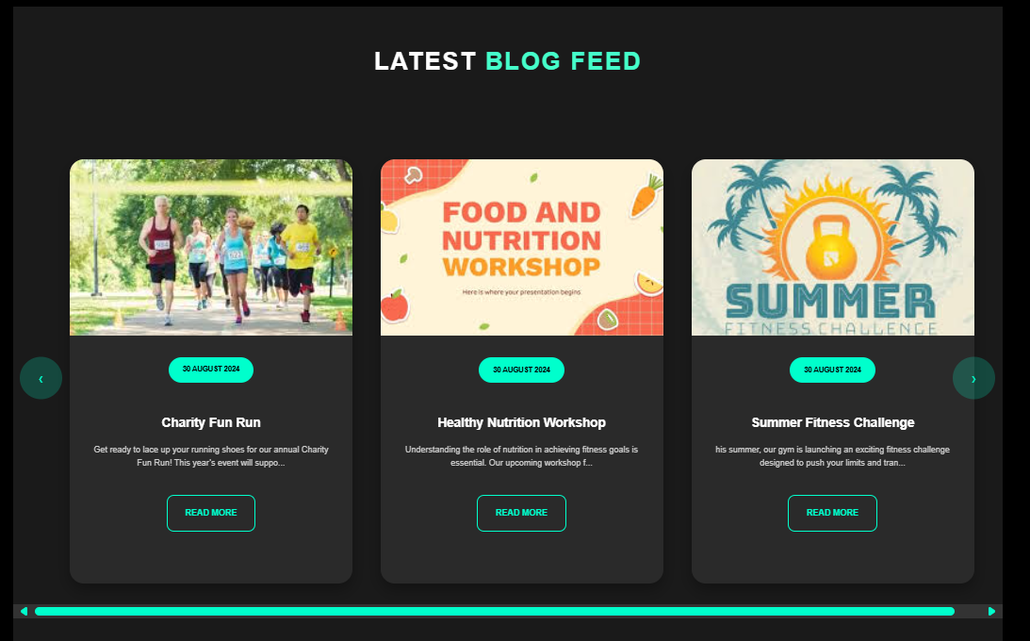

**Read More Button: Guests can click this button to view additional details such as the publication date, author, number of views, relevant images, and the full content of the post. The page also includes social media sharing options (e.g., Facebook, WhatsApp) and a commenting feature powered by Facebook, helping the club reach a broader audience. At the bottom, Related News suggests similar content that might interest the guest.**



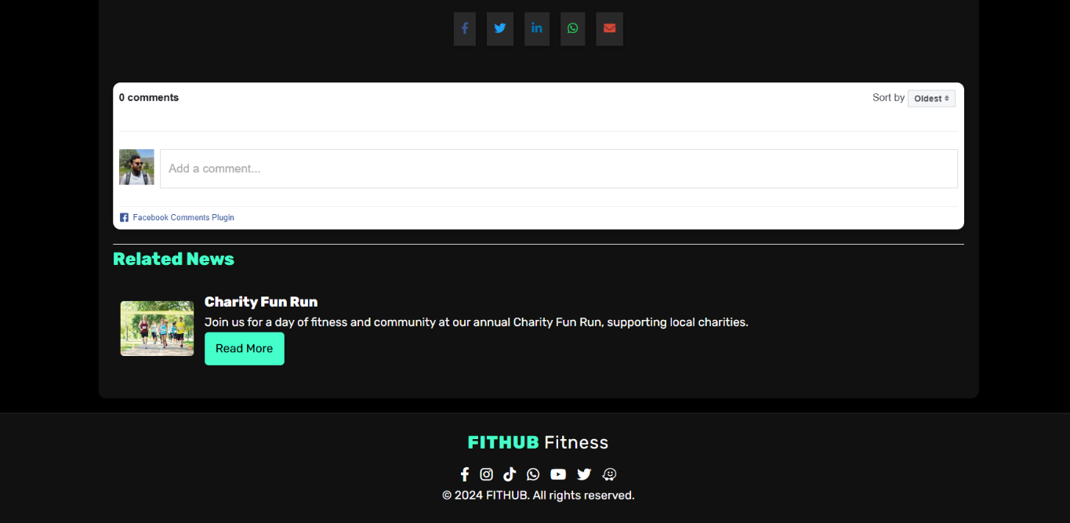

### Client Reviews

**Guests can browse through the Client Reviews section to see testimonials and feedback from current members. While guests can view these reviews, only registered members who have participated in courses can submit reviews, and submissions must be approved by a manager before being published.**

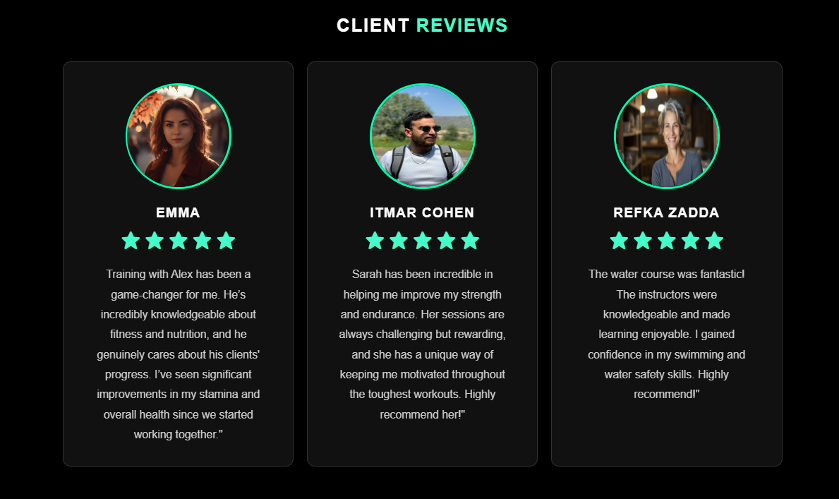

### BMI Calculator

**Since the club focuses on fitness, the website includes a BMI Calculator tool that guests can use to calculate their Body Mass Index (BMI). The result categorizes the guest as obese, regular, or underweight, providing a starting point for choosing the right courses or fitness plans.**

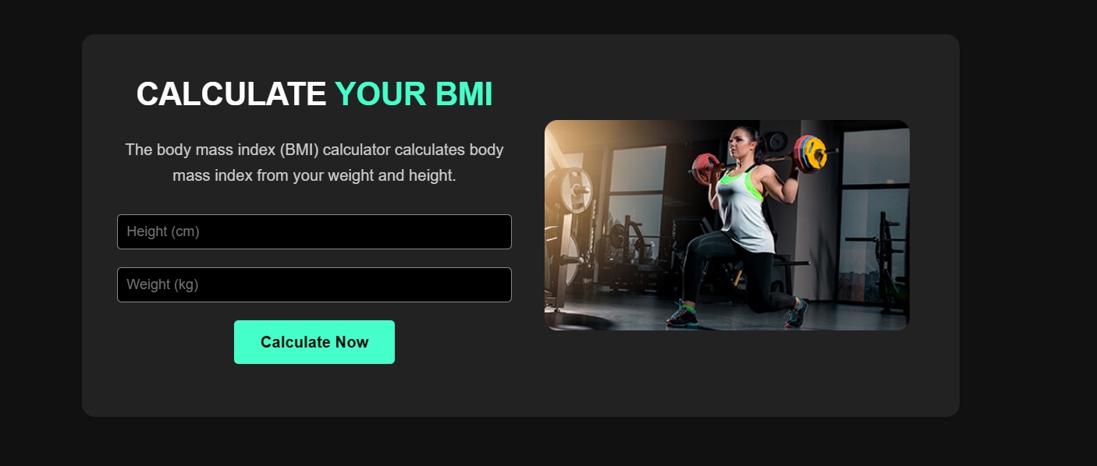





### Footer Section

**The final section of the homepage is the Footer, which contains essential information about the club, including contact details, terms of service, privacy policy, and links to social media profiles.**



## Member Experience

**Once a user logs in to the website, they transition from a guest to a member, gaining access to additional features and functionalities designed to enhance their experience at the club. Below is an overview of what members can do after logging in:**

### Post-Login Interface

**Navbar Changes: After logging in, the navbar at the top right of the screen changes. The "Login" and "Join Now" buttons are replaced by a Logout button and a User Icon. Clicking on the user icon redirects the member to their Personal Dashboard, where they can manage their account and track their activities.**



### Course Registration

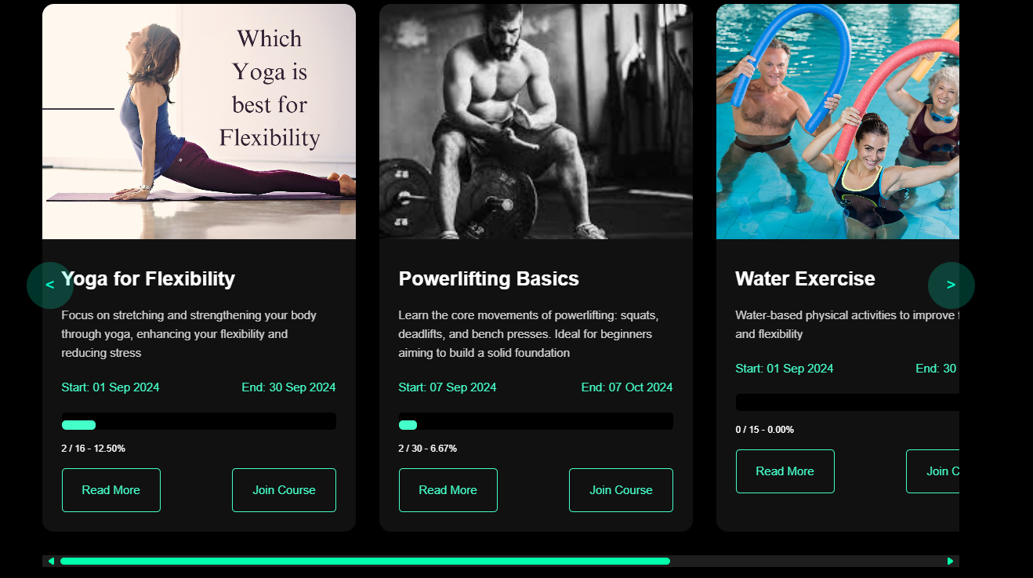

**After join course click: As a logged-in member, you can now register for courses directly through the website. When you select a course and click on the registration button, most of your details, such as email, name, and phone number, are pre-filled based on your account information. However, you'll need to enter sensitive payment details manually, including credit card information or choose alternative payment options like PayPal.**

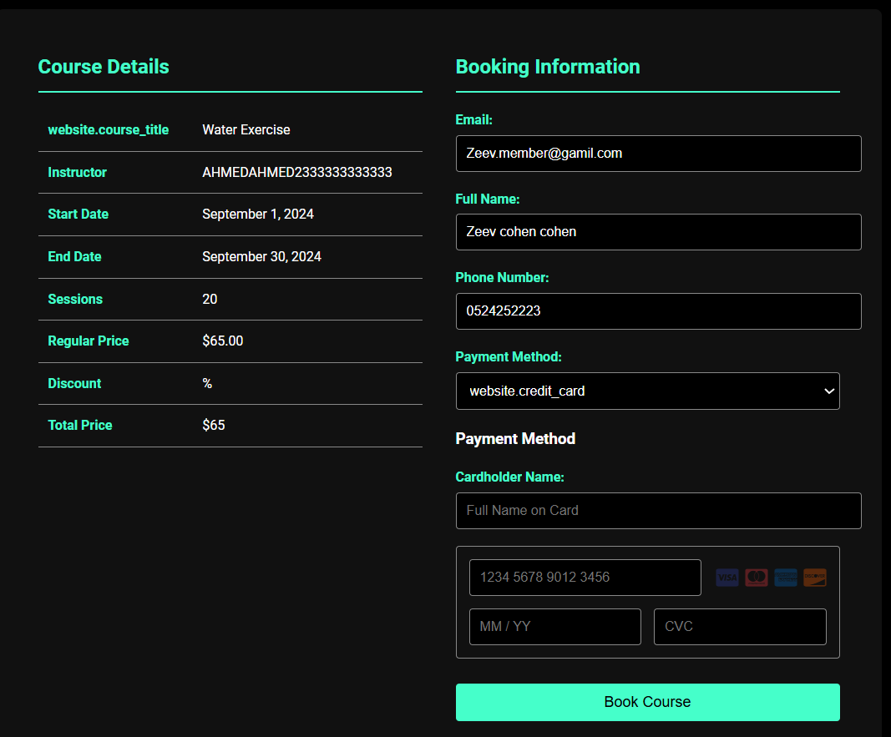

Registration Outcomes: **After completing the registration form and submitting it, you will encounter one of the following messages:**

* **Invalid Information: If any of the entered details are incorrect or missing, an error message will prompt you to correct them.**

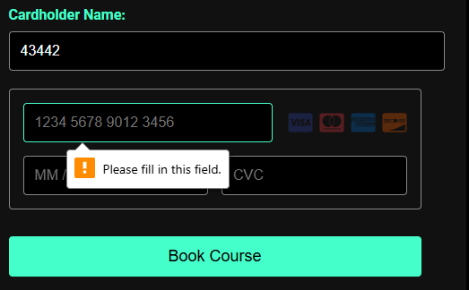

* **Already Registered: If you are already enrolled in the course, you’ll receive a notification indicating that you cannot register for the same course twice.**



* **Successful Registration: If everything is correct, a success message will confirm your enrolment in the course.**

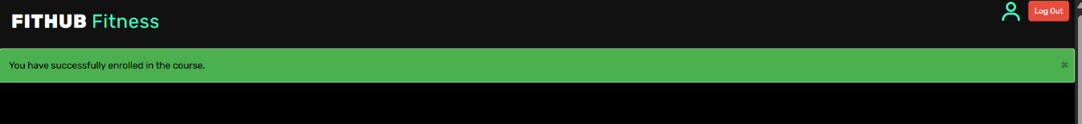

### Personal Dashboard

**The Personal Dashboard is the central hub for members, offering various tools to manage their activities and view their progress**

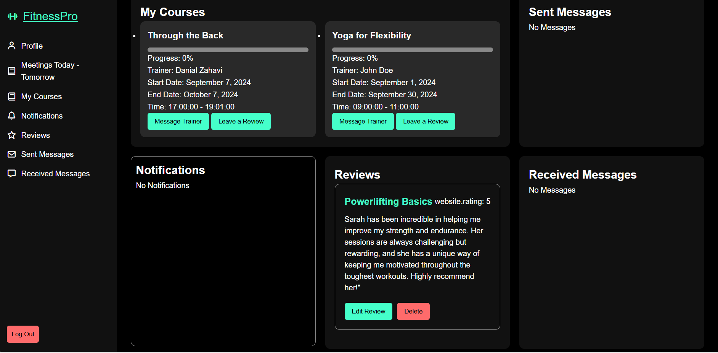

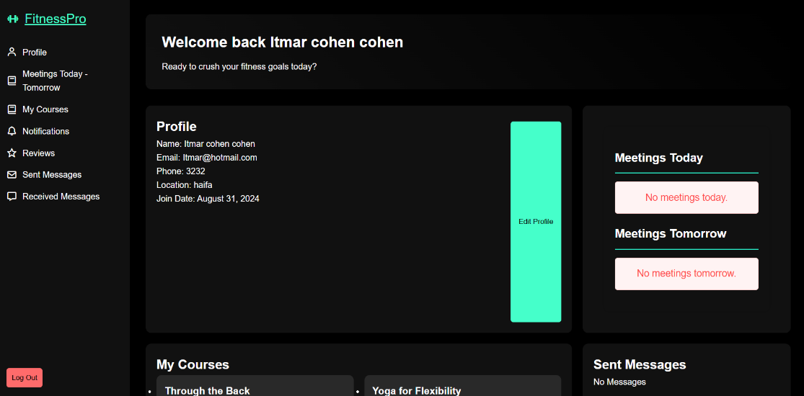

Profile: **This section contains personal information such as your name, email, phone number, join date, and more. Members can update their details as needed to keep their profiles current.**

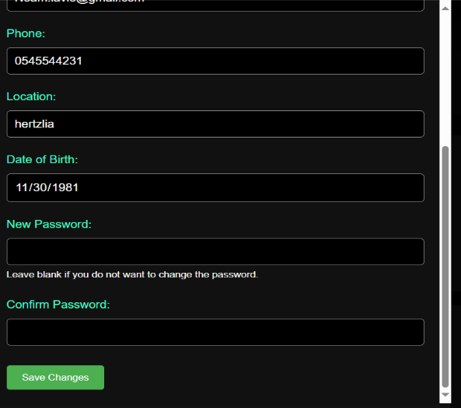

### My Courses:

**This section displays all the courses you are currently enrolled in. For each course, you can view:**

**Course Progress: Track how far you've come in the course.**

**Instructor Information: See the name of the instructor leading the course.**

**Schedule Details: Check the start and end dates, days, and times for each session.**

**Each course in this section comes with two key buttons:**

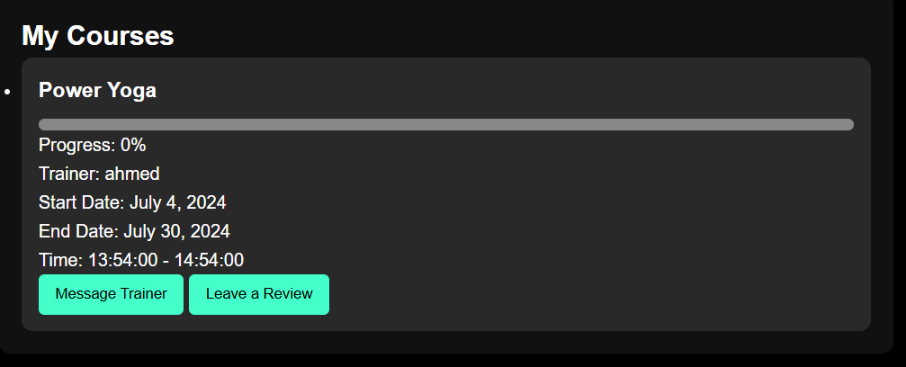

### Send Message to Trainer :

**Use this button to send a message to your instructor. You can ask questions or request feedback, and you’ll receive responses directly through the platform.**

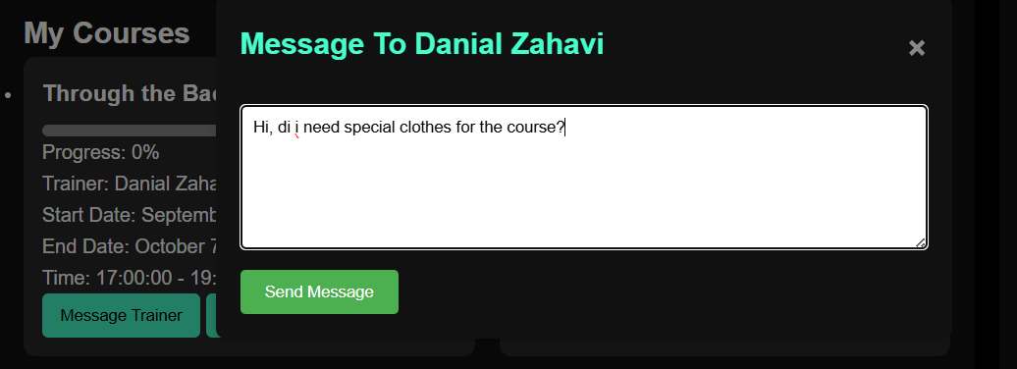

**After received a message from trainer:**

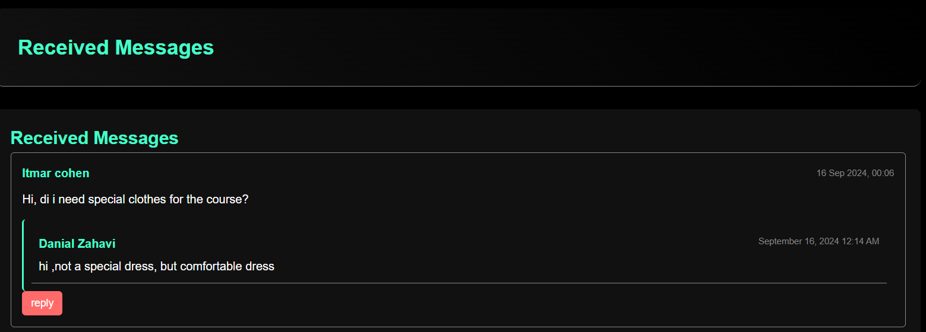

**Leave a Course Review: After completing a course, you can leave a rating and a detailed review. This review will be submitted to a manager for approval, and if deemed relevant, it will be published on the website.**

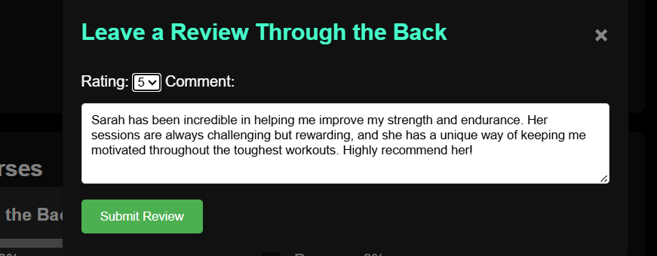

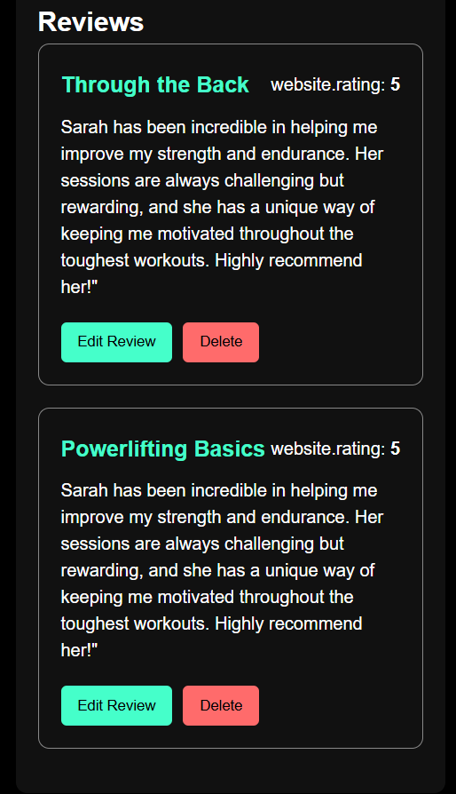

### Notifications

**Members receive updates and notifications from both managers and instructors related to their courses. This ensures that you are always informed about any changes, upcoming events, or important announcements.**

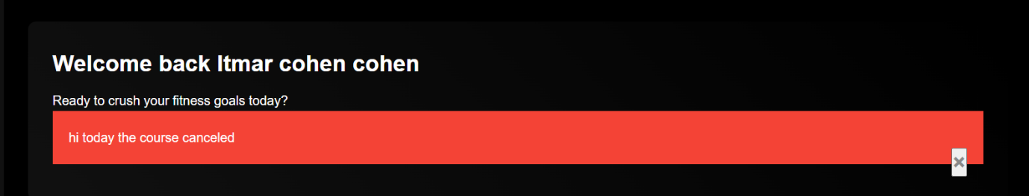

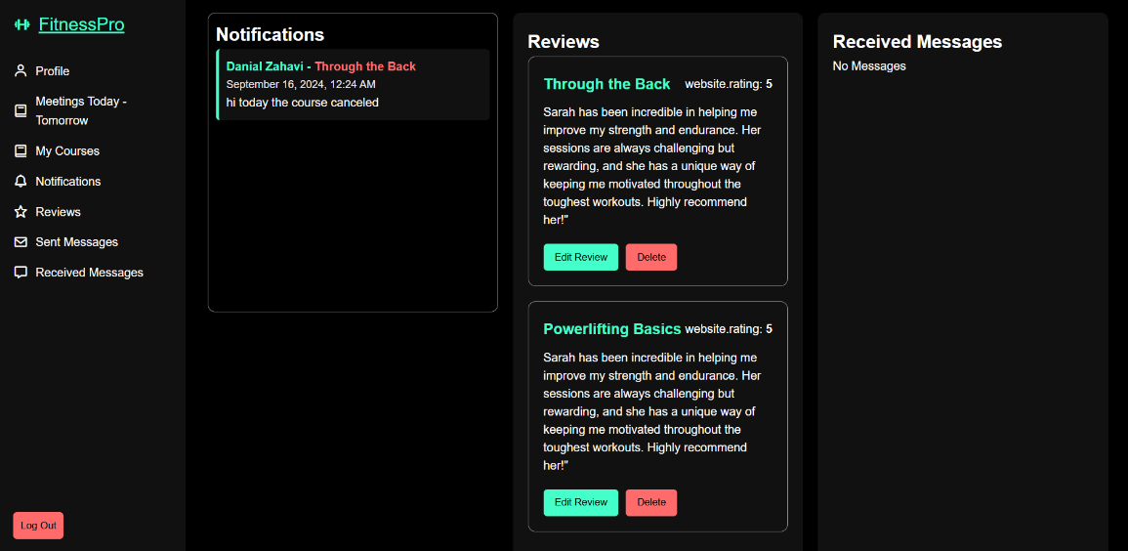

### Messages

**The Messages section allows you to manage all your communications within the platform:**

**Sent Messages: View all the messages you’ve sent to instructors or managers.**

**Received Messages: Access replies and other communications from instructors .**

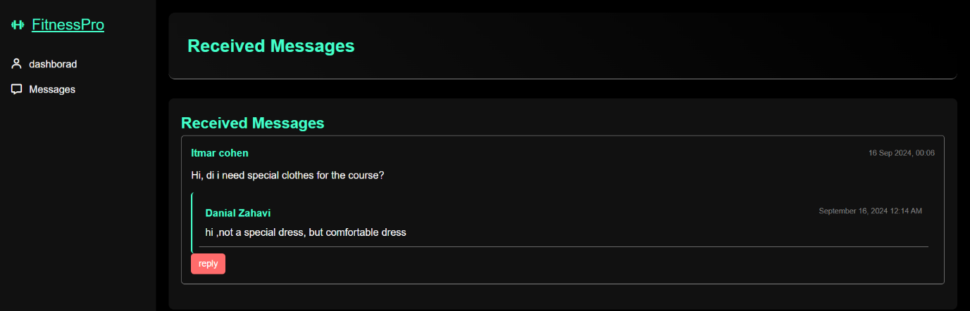

## Instructor Experience

**As an instructor, you have access to a range of tools that allow you to manage your courses, communicate with participants, and update your personal information. Below is an overview of the functionalities available to instructors:**

### Personal Information

**Instructors have access to their personal profile, where they can view and update their details, similar to the functionality available to members. This includes basic information such as name, email, phone number, and other relevant data. Keeping this information up-to-date ensures accurate communication and smooth operation within the platform.**

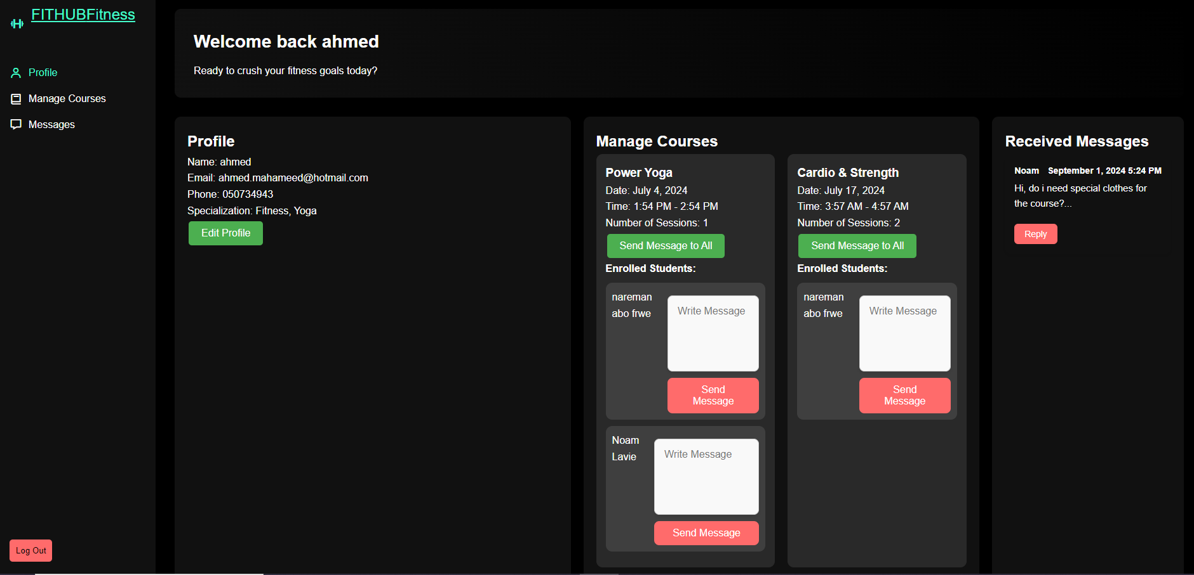

**\*\* I Add this section:**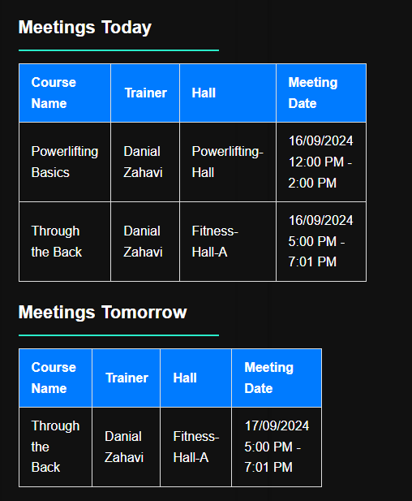

### Course Management

**As an instructor, you can view all the courses you are currently teaching. For each course, you can access detailed information, including:**

**Course Name**

**Schedule: Start and end dates, session days, and times.**

**Enrolled Participants: A list of all members registered for the course.**

**Course Progress: Overview of the progress made in the course.**

**This section helps instructors stay organized and informed about the status and details of each course they are responsible for.**

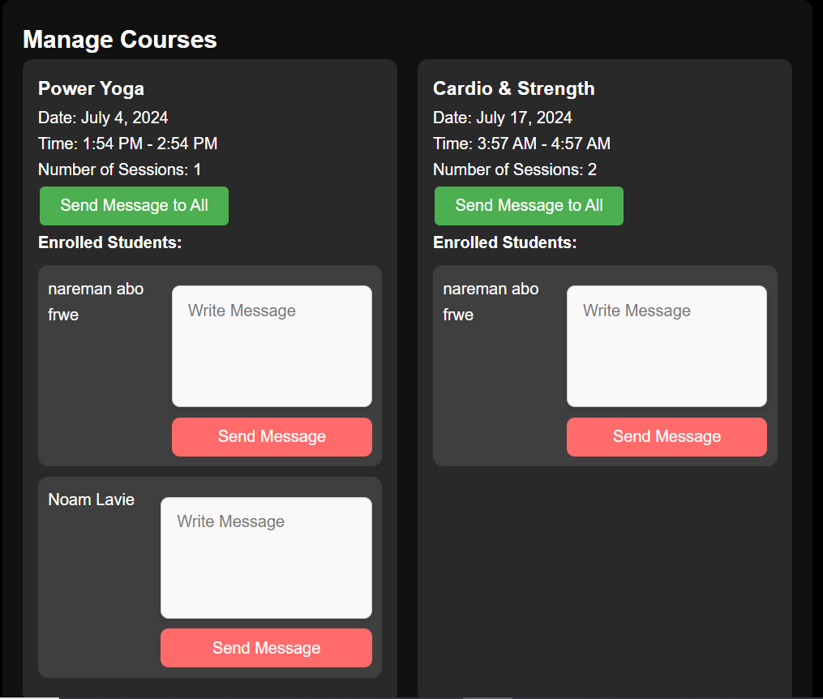

### Communication Tools

**Effective communication is crucial for course management, and the platform provides instructors with powerful tools to stay connected with their participants.**

**Messaging Options: Within each course, instructors have two primary options for sending messages:**

**Send Message to All Participants: This option allows instructors to broadcast a message to all members enrolled in a specific course. It’s useful for sharing important updates, reminders, or general announcements relevant to the entire class. The feature can be accessed through the Send Message to All button within the course management interface.**

**Send Message to Specific Member: If an instructor needs to communicate with a specific member, they can do so through the Send Message to a Specific Member option. This allows for more personalized communication, whether it’s addressing individual concerns, providing feedback, or offering additional support.**

**These communication tools ensure that instructors can maintain clear and effective contact with their participants, fostering a supportive and well-organized learning environment.**

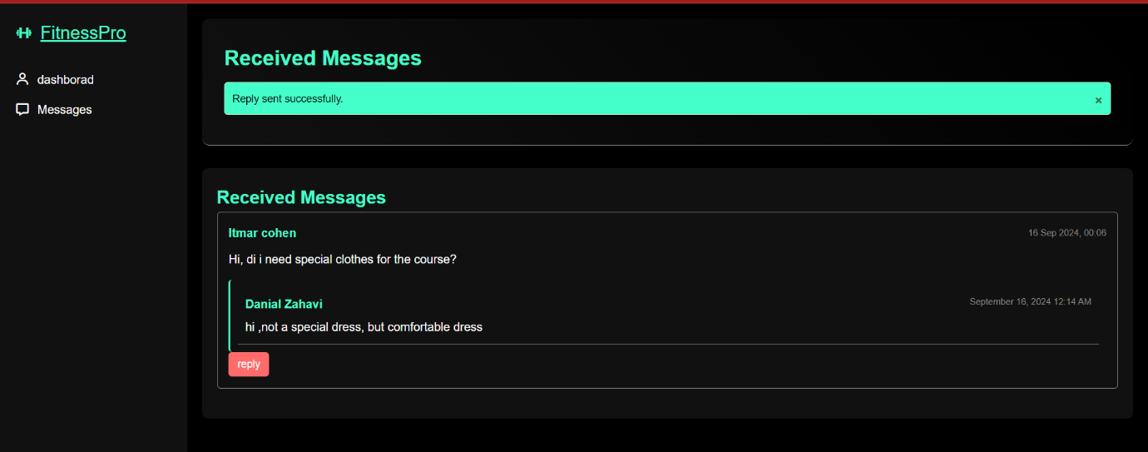

## Admin Experience

**The Admin panel is designed to efficiently manage all aspects of the sports club. Below is a detailed guide to the functionalities available to administrators and staff:**

### Admin Dashboard

**The Admin Dashboard provides a central overview of the sports club's key metrics, offering quick insights into the club’s operations. This section is designed to help administrators monitor the club's activities at a glance.**

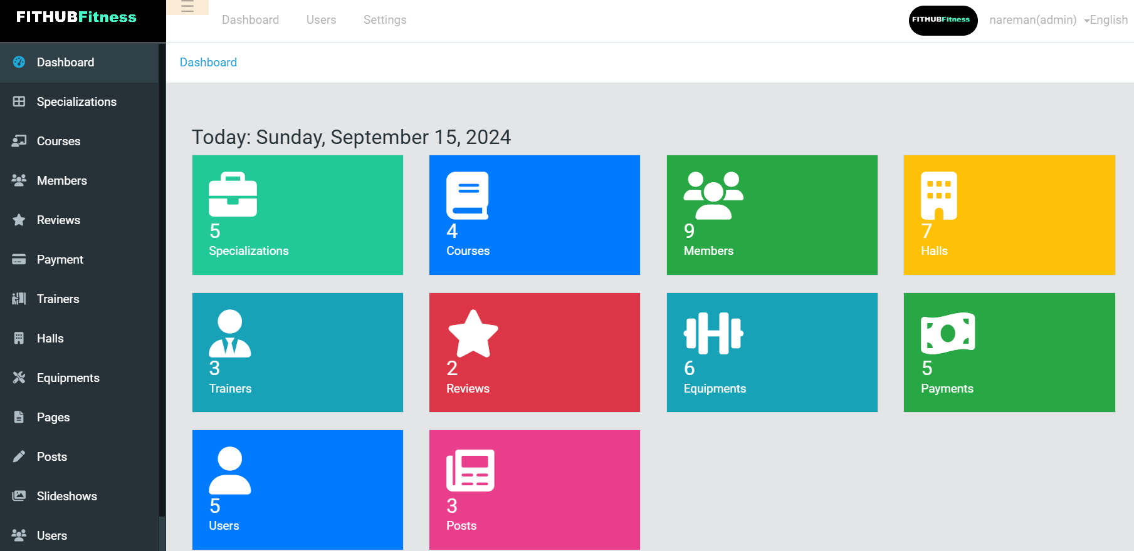

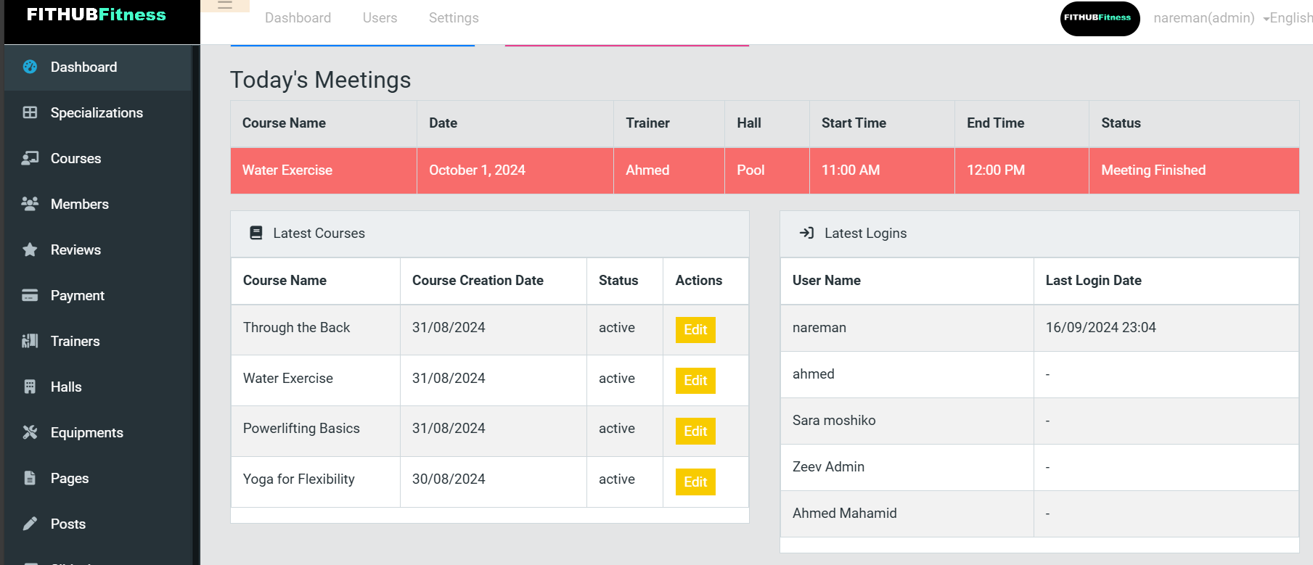

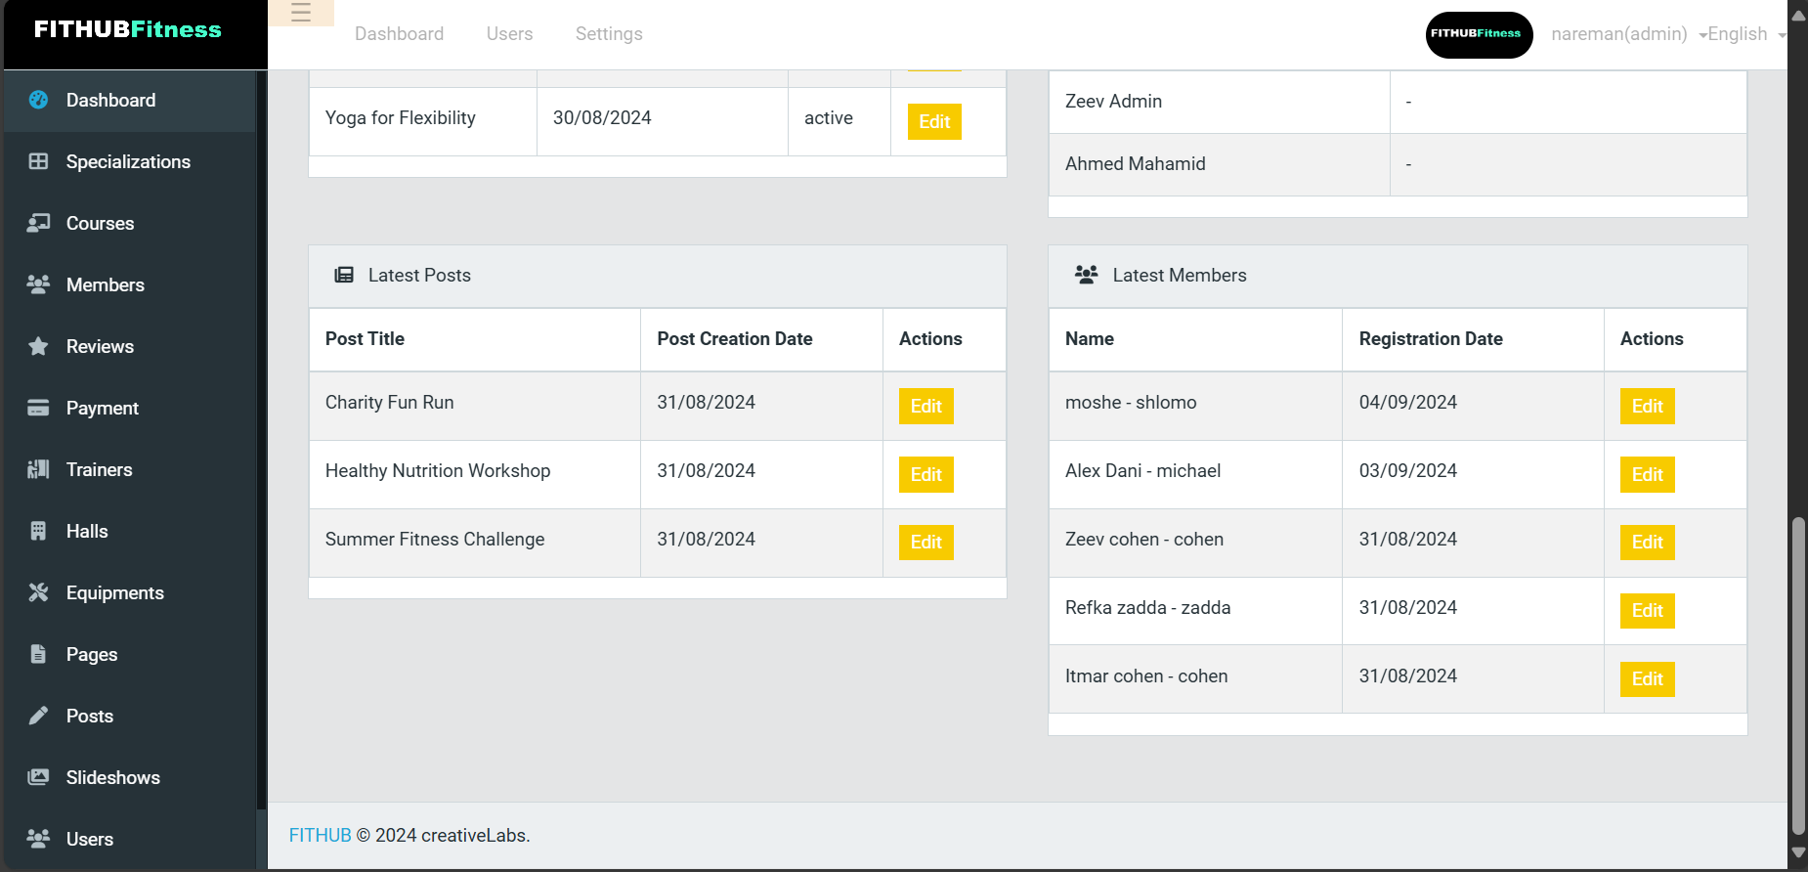

### Specializations:

**This section allows administrators to assign specific professions to instructors. Currently, the feature is used to categorize instructors based on their areas of expertise. While the functionality is limited at the moment, it may play a more significant role in the future as the system evolves.**

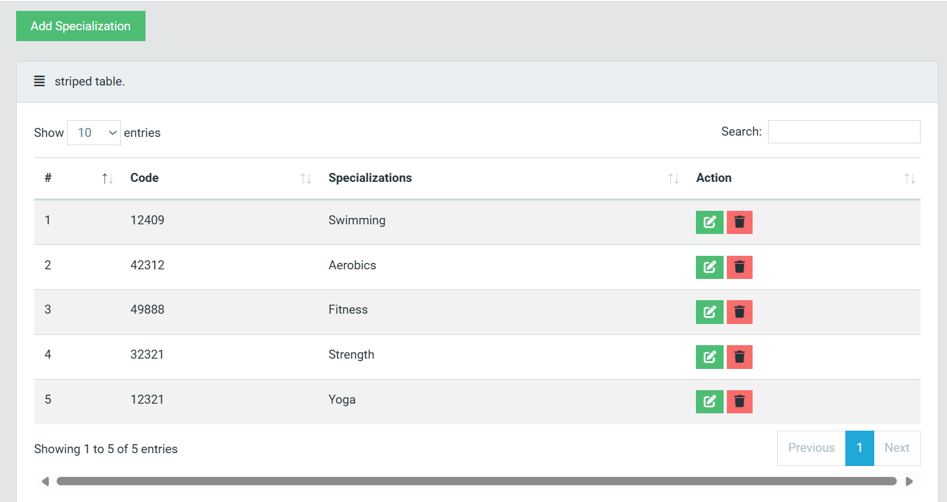

### Courses

**Course Management: This section provides a comprehensive overview of all courses offered at the club. The courses are displayed in a table that includes essential details such as:Course NameProfession: The relevant field of expertise.Instructor: The assigned instructor for the course.Hall/Room: The location where the course is conducted.Status: Indicates whether the course is Active (currently running or upcoming) or Inactive (either completed or canceled due to insufficient enrollment).**

**by clicking on Add course, I can add new courses.**

**Filtering and Search: To enhance efficiency, the table includes a search bar that allows administrators to quickly find specific courses by typing in keywords. Additionally, the "Show Entries" dropdown enables users to customize the number of courses displayed. There is also an option to filter courses based on their status (Active/Inactive).**

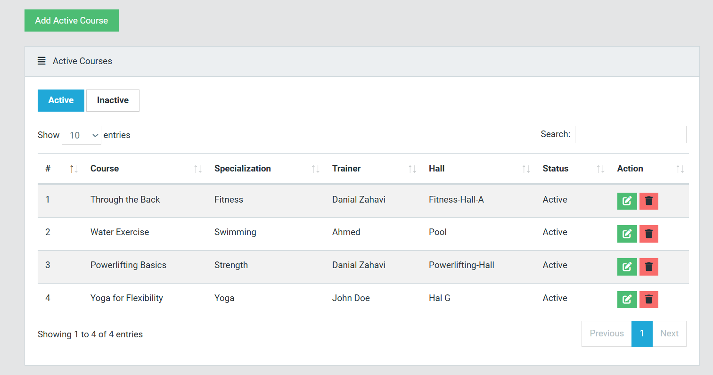

**Detailed Course Information: By clicking on a specific course, administrators can access detailed information, including:**

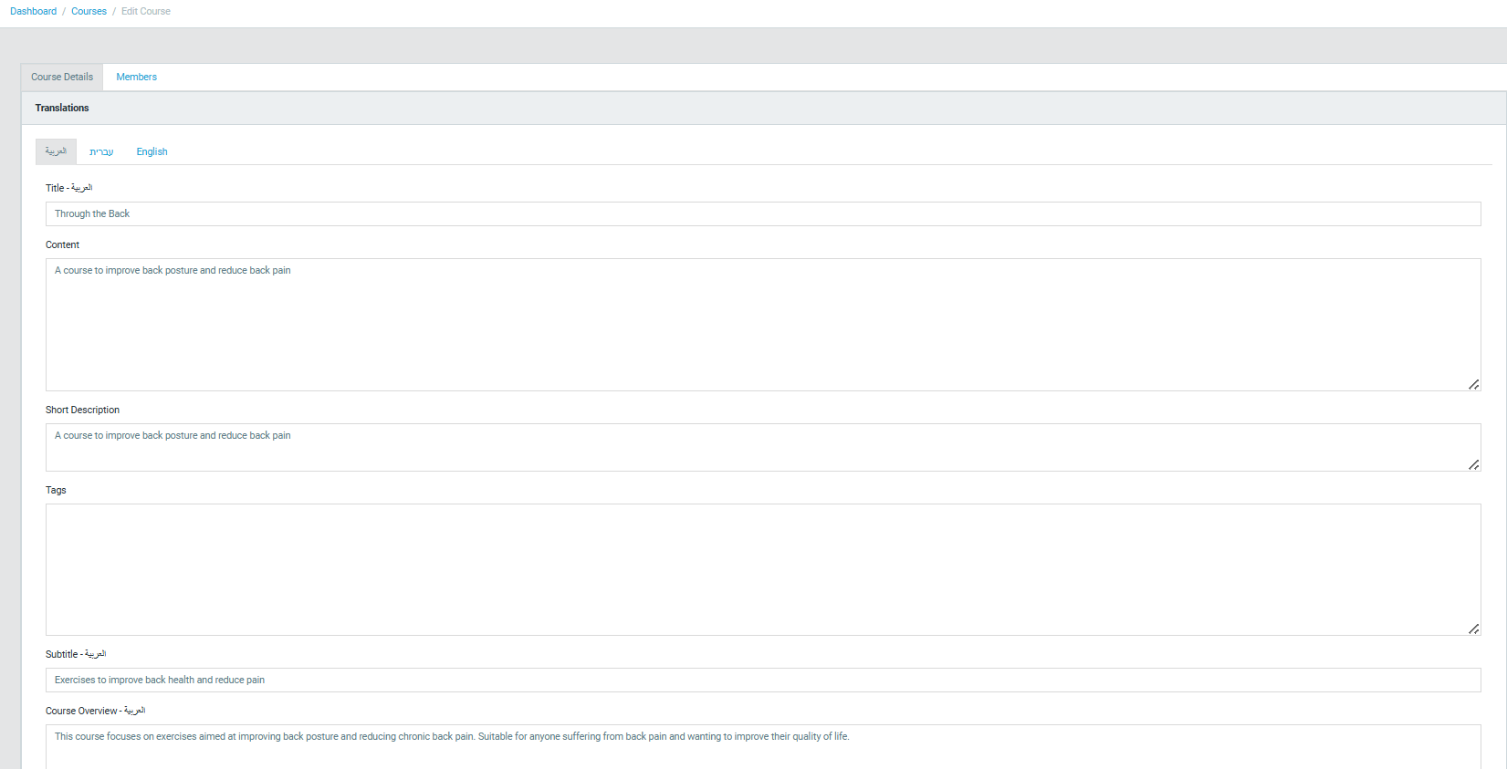

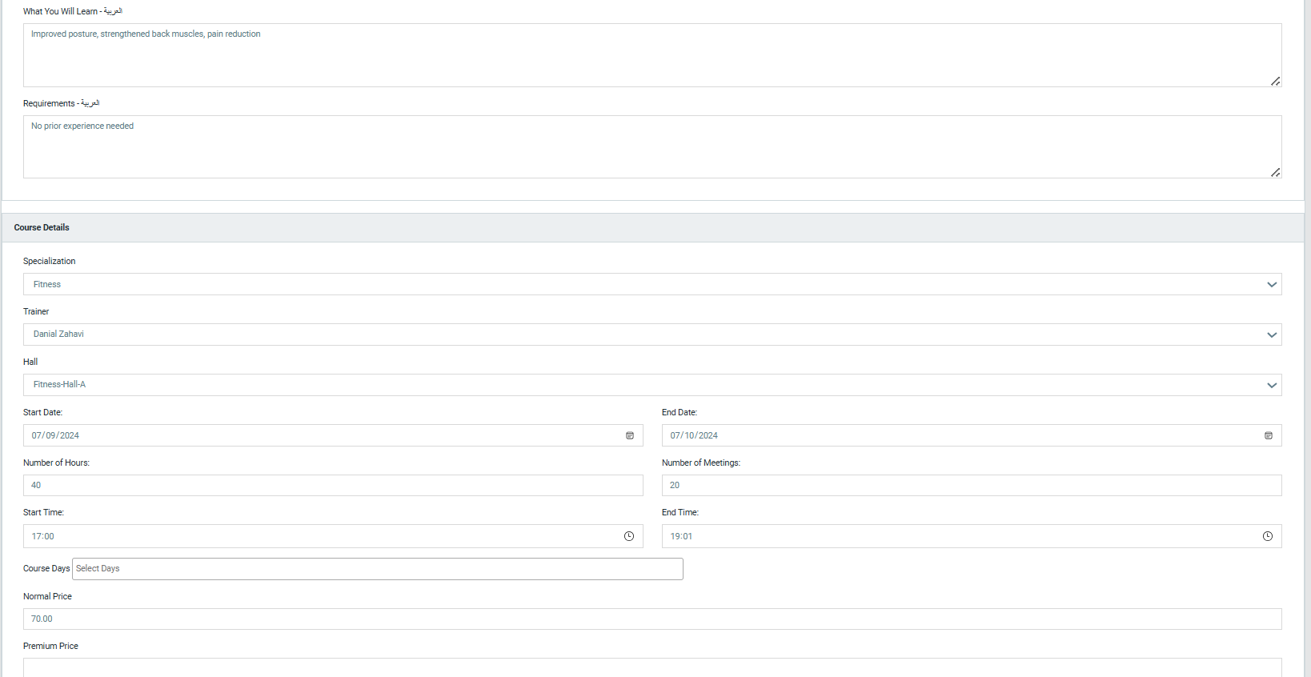

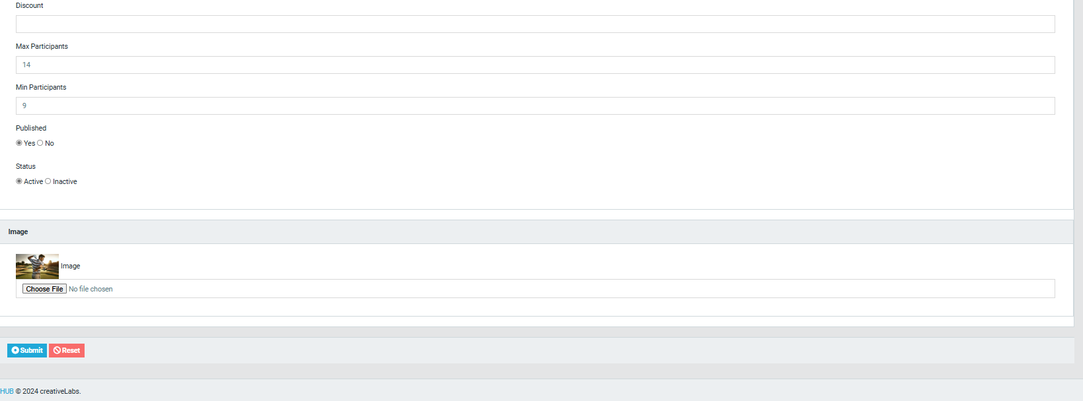

**Members: A list of participants enrolled in the course, and can add members by insert ID number.**

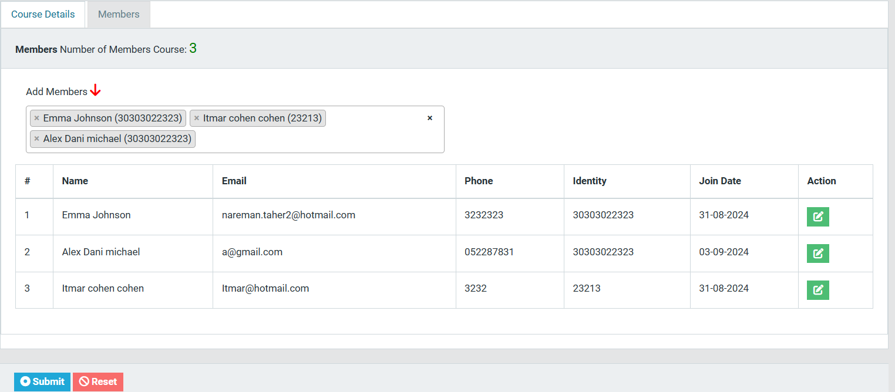

### Members

**Member Management: This section lists all registered members, displaying key details such as:User IDIdentification NumberNamePhone NumberJoin Date.**

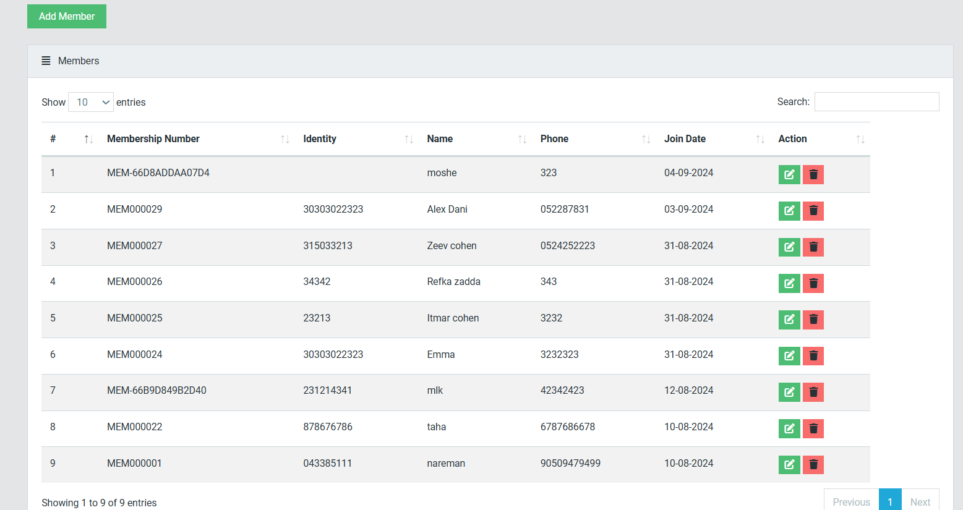

**Detailed Member Information: By clicking on a member's profile, administrators can view comprehensive details:**

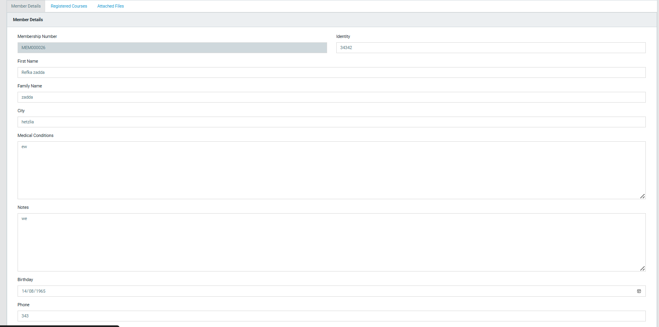

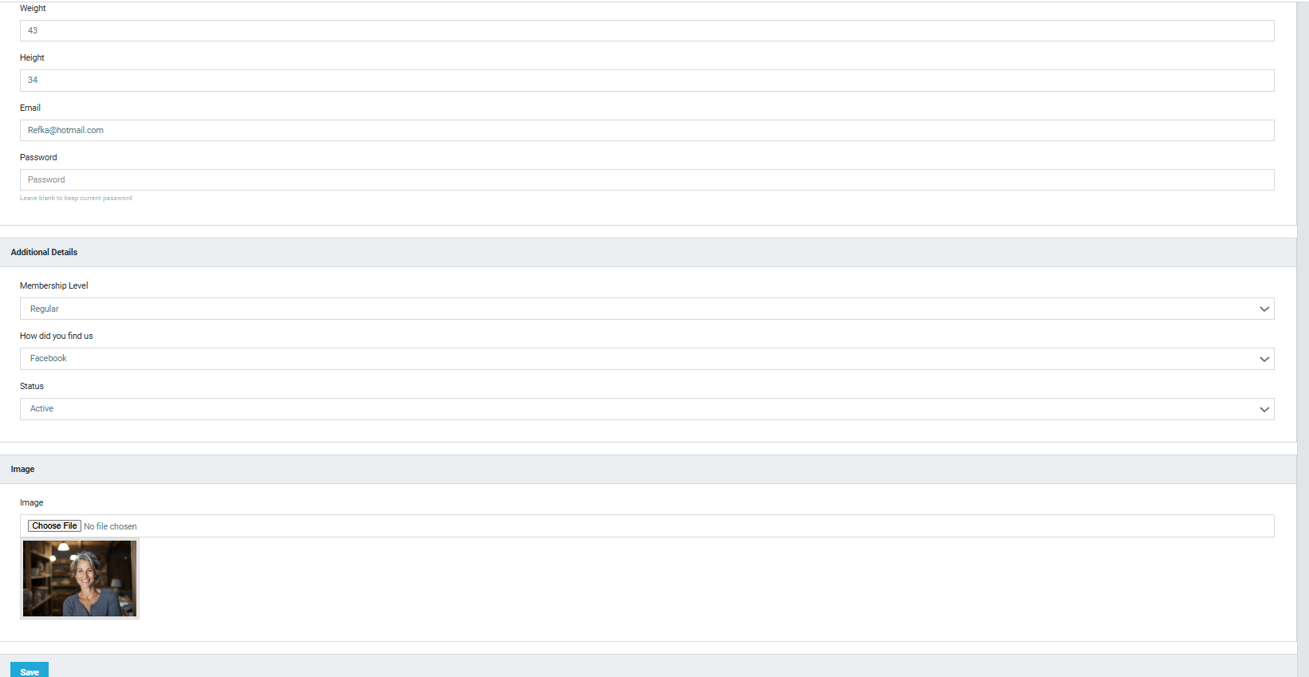 **Enrolled Courses: A list of courses the member is registered for.**

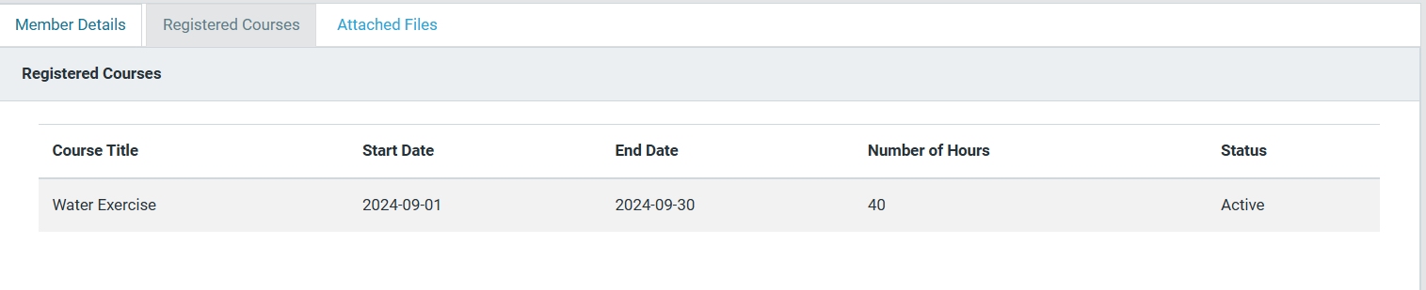

**Attached Files: Documents that members may need to share, such as medical certificates.**

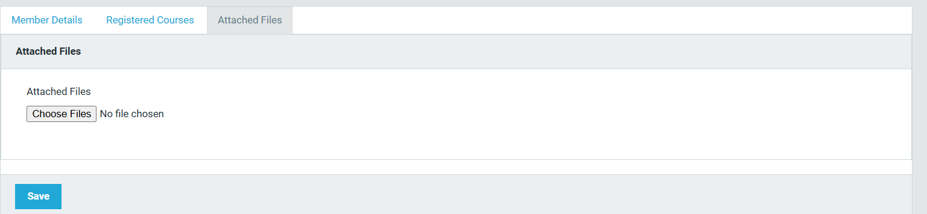

**Adding Members: Administrators have the ability to manually add new members and enroll them in courses, ensuring a flexible and personalized registration process.** 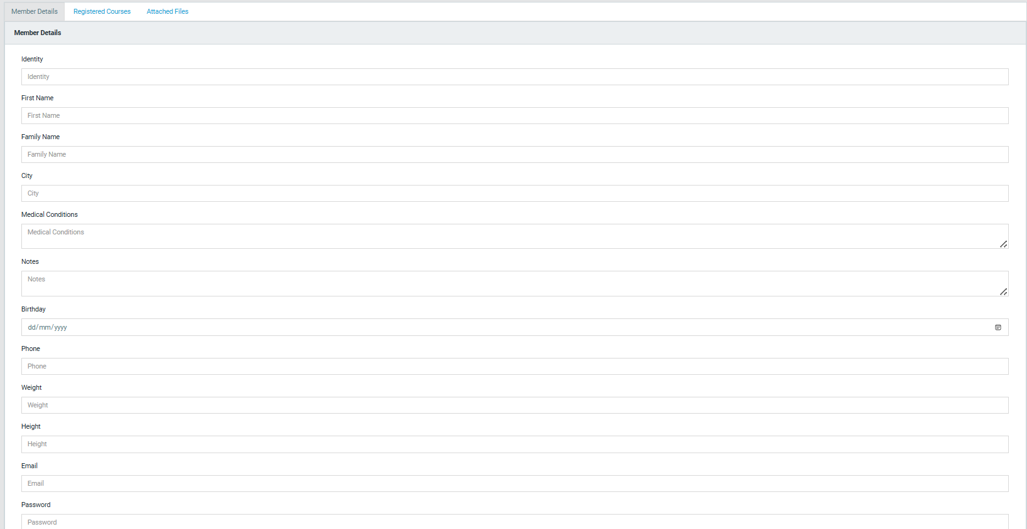

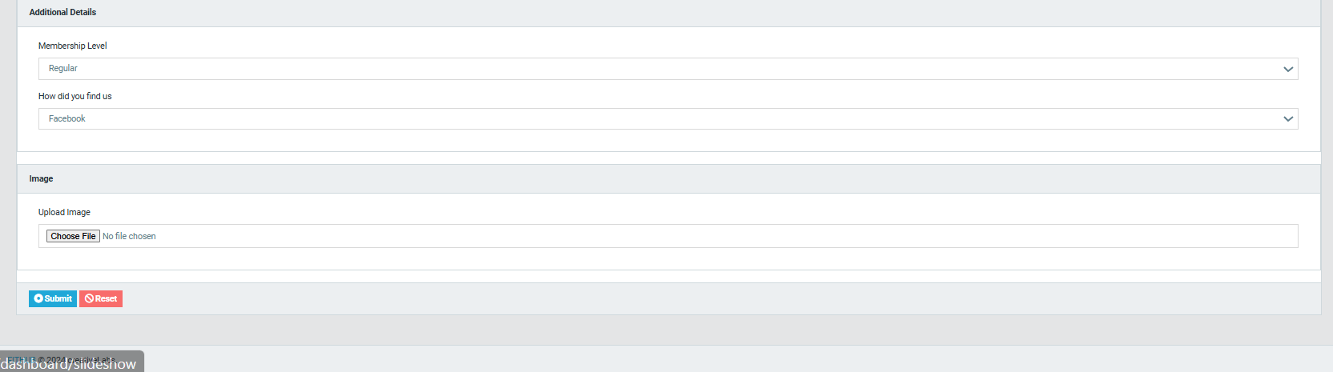

### Reviews

**Review Management: This section allows administrators to manage user reviews. The table displays:Username: The user who submitted the review.Course Name: The course being reviewed.Rating ScoreStatus: Whether the review is Published (visible on the website) or Unpublished (awaiting approval).**

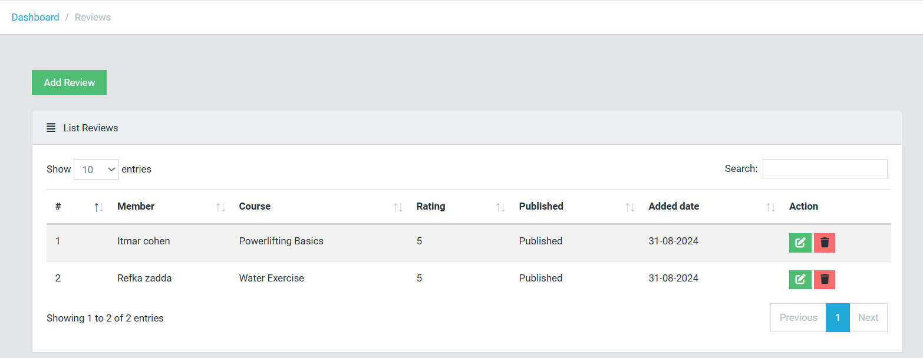

**Review Approval Process: Reviews are not published automatically. By default, all reviews are set to Unpublished. Administrators must review the content and decide whether to approve and publish the review.** 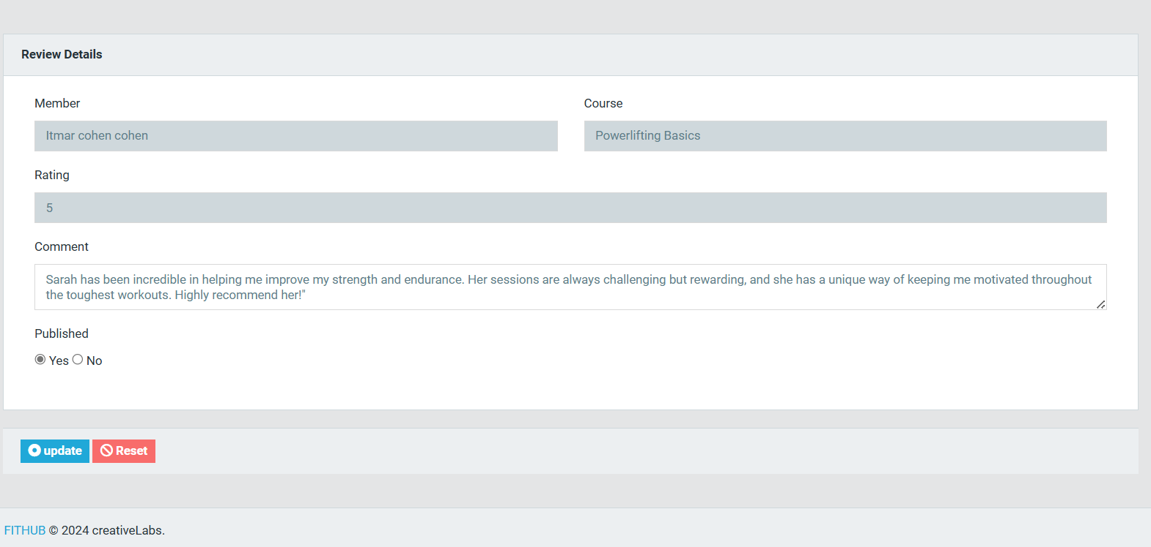

### Instructors/Trainers

Instructor Management:

**Similar to members, this section lists all instructors, showing key details about each instructor.**

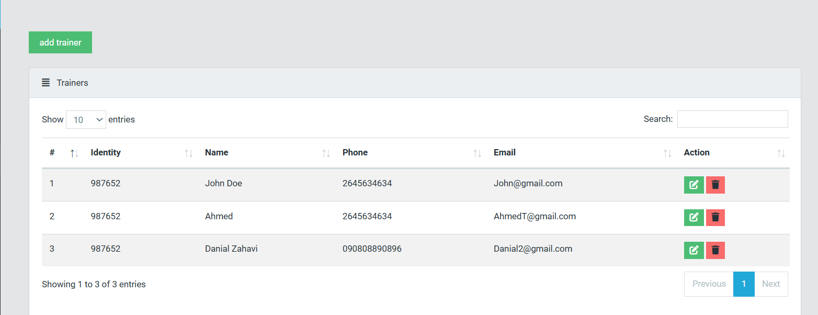

**Detailed Instructor Information: Clicking on an instructor's profile provides more information, including:**

**Personal Details: Basic information such as contact details.**

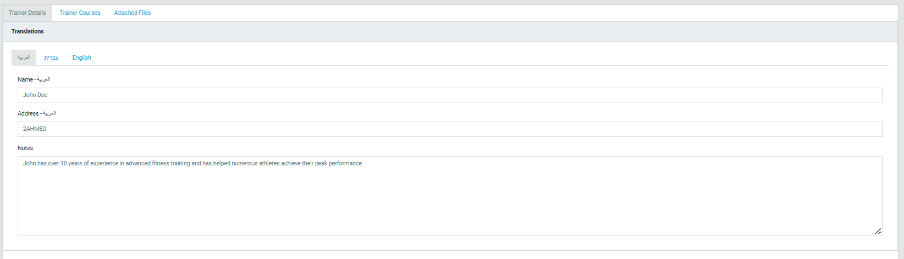

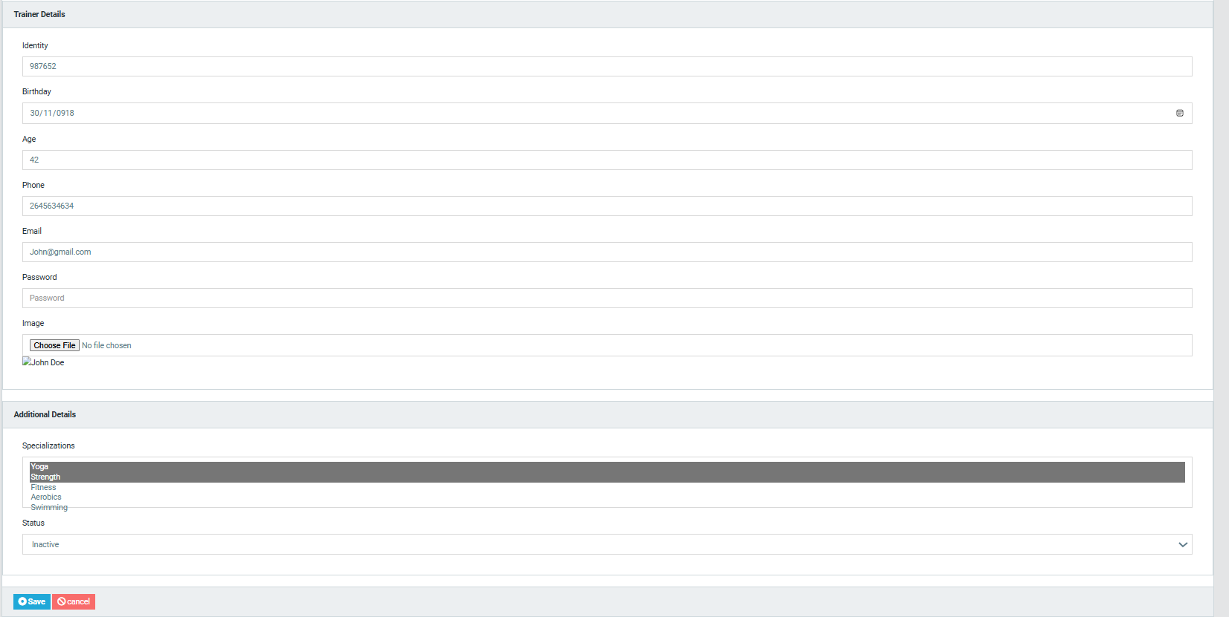

**Trainer Courses: The courses that the instructor is responsible for.**

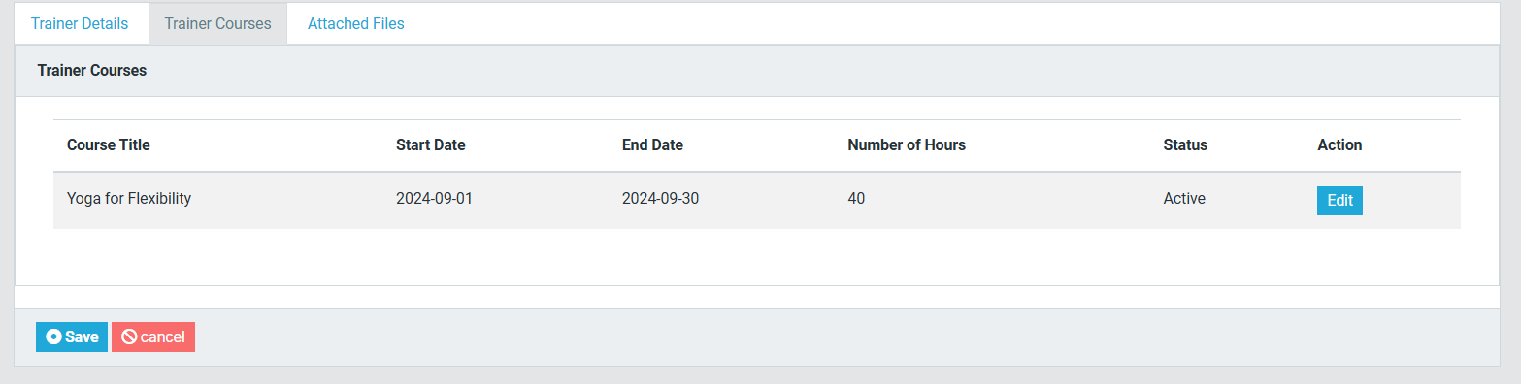

**Attached Files: Documents like certifications or resumes.**

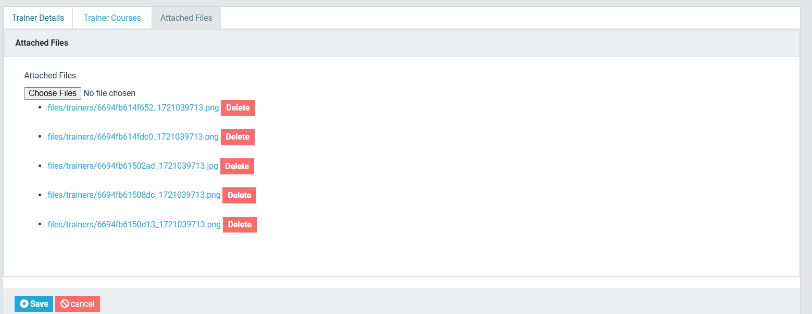

**Adding Instructors: Administrators can add new instructors to the system by click on add trainer , assigning them to specific courses.** 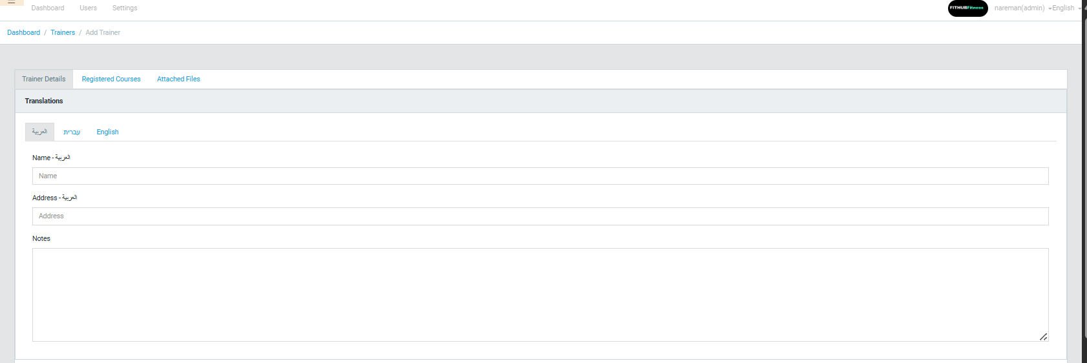

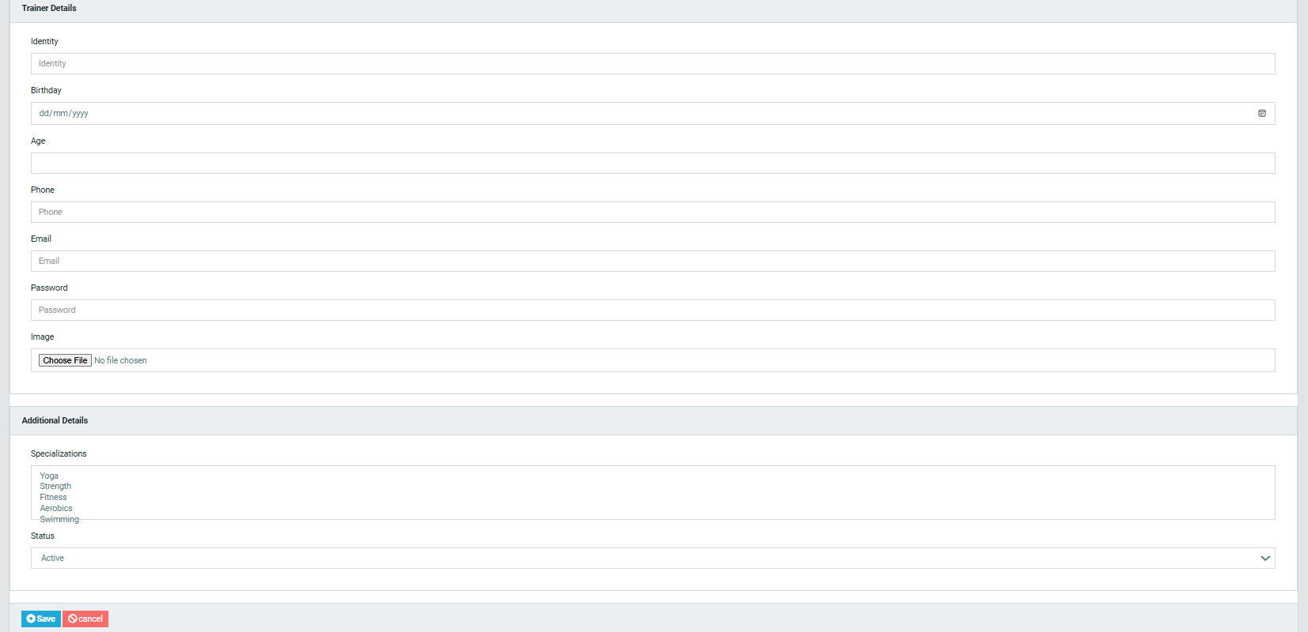

### Halls

**Hall Management: This section provides an overview of all halls or rooms available in the club. The table includes:Hall NameCapacity: The maximum number of people the hall can accommodate.Status: Indicates whether the hall is Available or Occupied.**

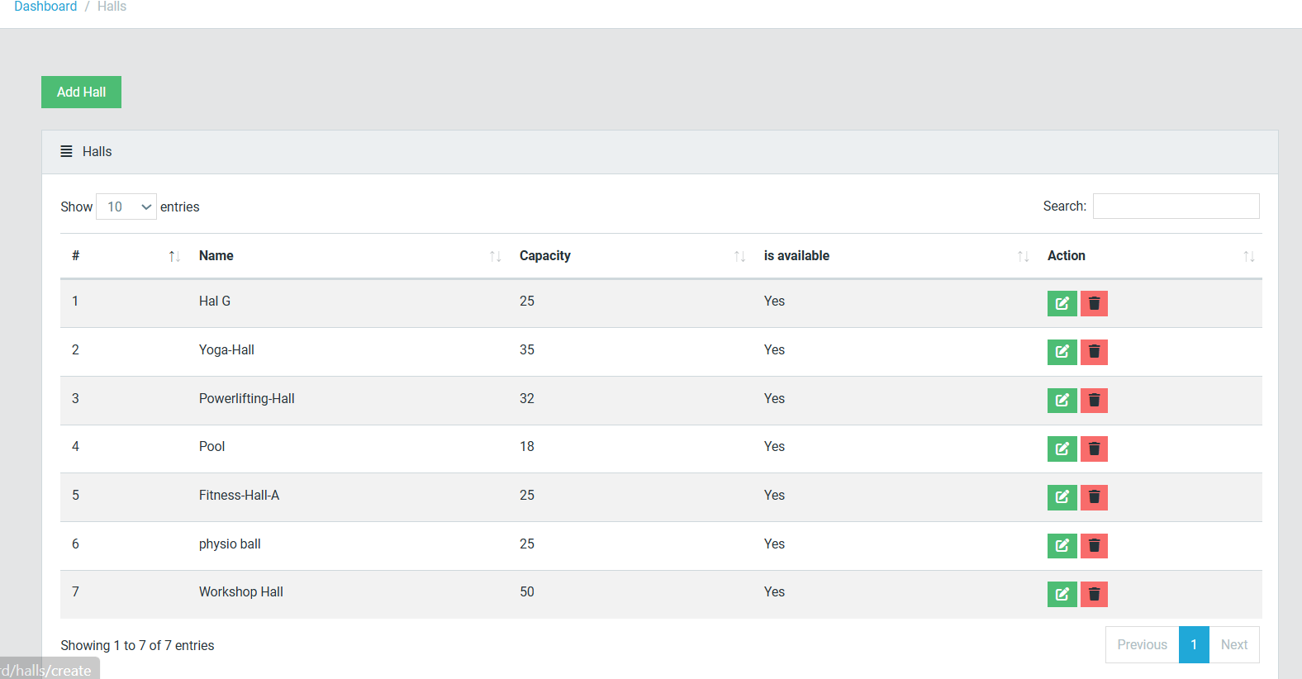

**Detailed Hall Information: By clicking on a hall, administrators can access additional details, including the equipment available in the hall.**

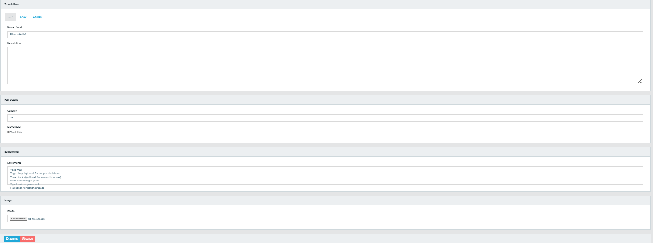

### Equipment

Equipment Management: **This section lists all equipment in the club, providing details such as:Equipment NameLocation: The hall or room where the equipment is located.Quantity**

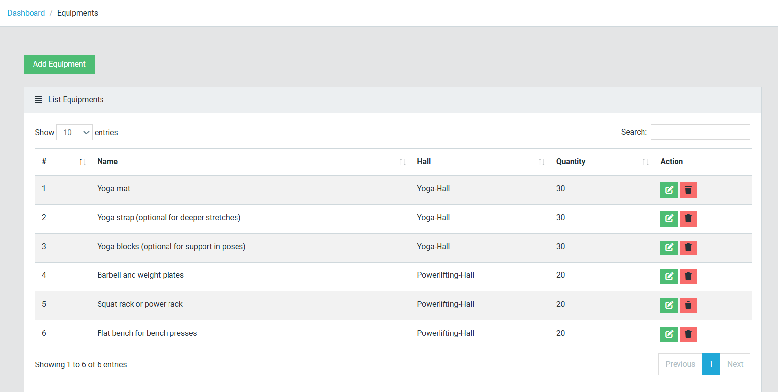**Detailed Equipment Information: Clicking on a piece of equipment provides more detailed information about it, including specifications and usage guidelines.**

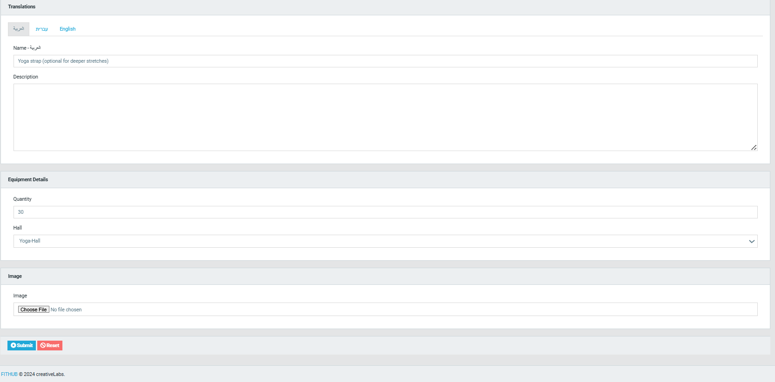

### Pages

Page Management:Administrators can update the content on various sections of the club's official website, such as the "About Us" page, ensuring that the information presented is accurate and up-to-date.

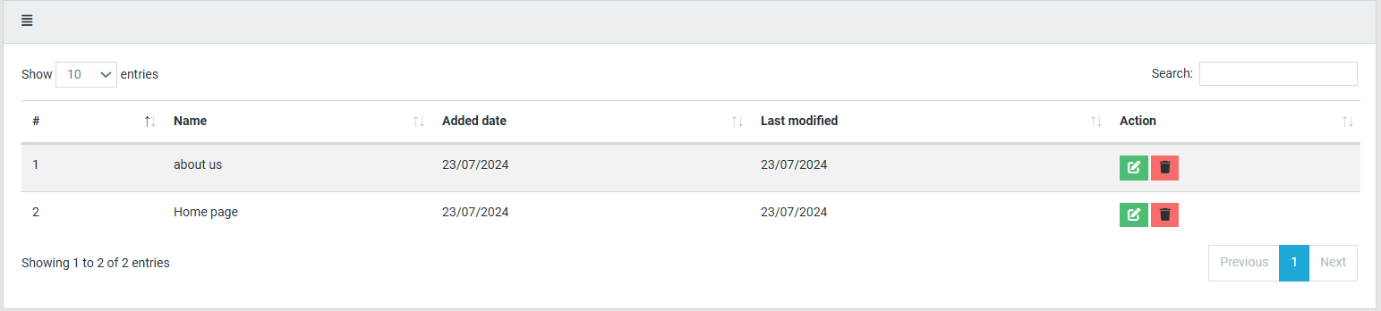

### Posts

**Blog Feed Management: This section allows administrators to manage the club’s blog posts.**

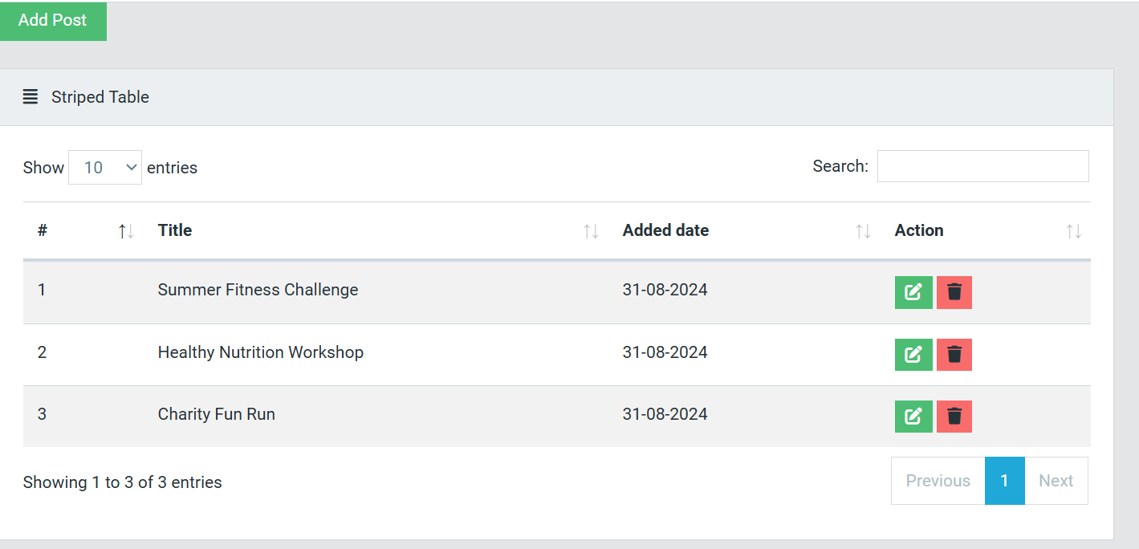

**Viewing Posts: By clicking on a post, administrators can see more detailed information.**

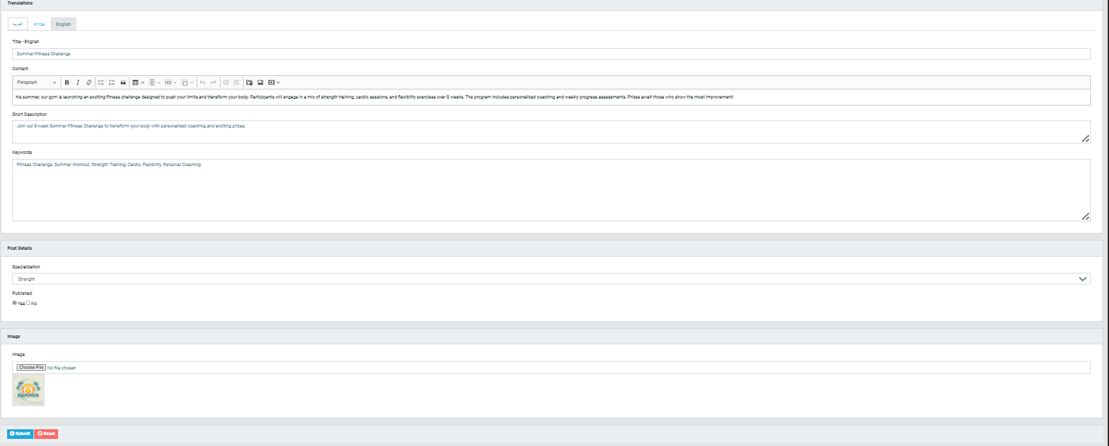

**Adding New Posts: Administrators can create and publish new posts by clicking the "Add Post" button. The process includes filling in necessary details and uploading relevant images.**

**Deleting Posts: Administrators can also delete outdated or irrelevant posts as needed.** 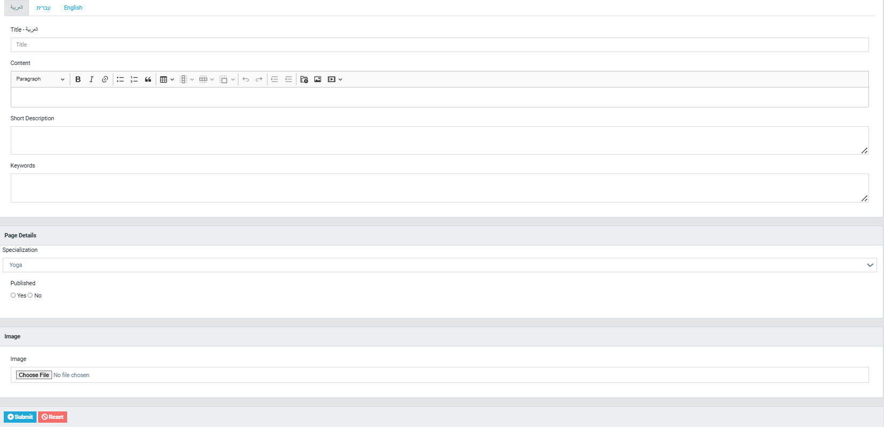

### Slideshows:

Slideshow Management: While not currently in use, this section was added to potentially showcase courses or blog posts in a slideshow format. Although this feature is not active, it has been retained for possible future use.

### Users

User Management: This section lists all staff members of the club, including details such as:NameRole: Possible roles include Admin, Writer, or Editor.

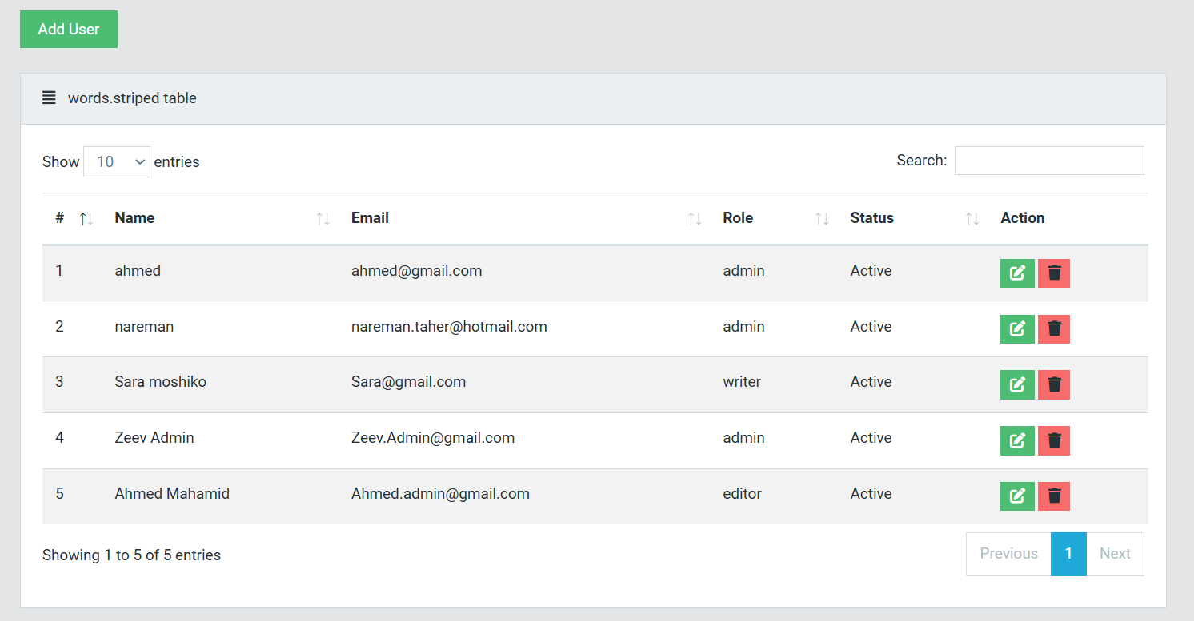

**Adding New Staff: Administrators can add new staff members by clicking the "Add User" button, assigning them appropriate roles within the system.**

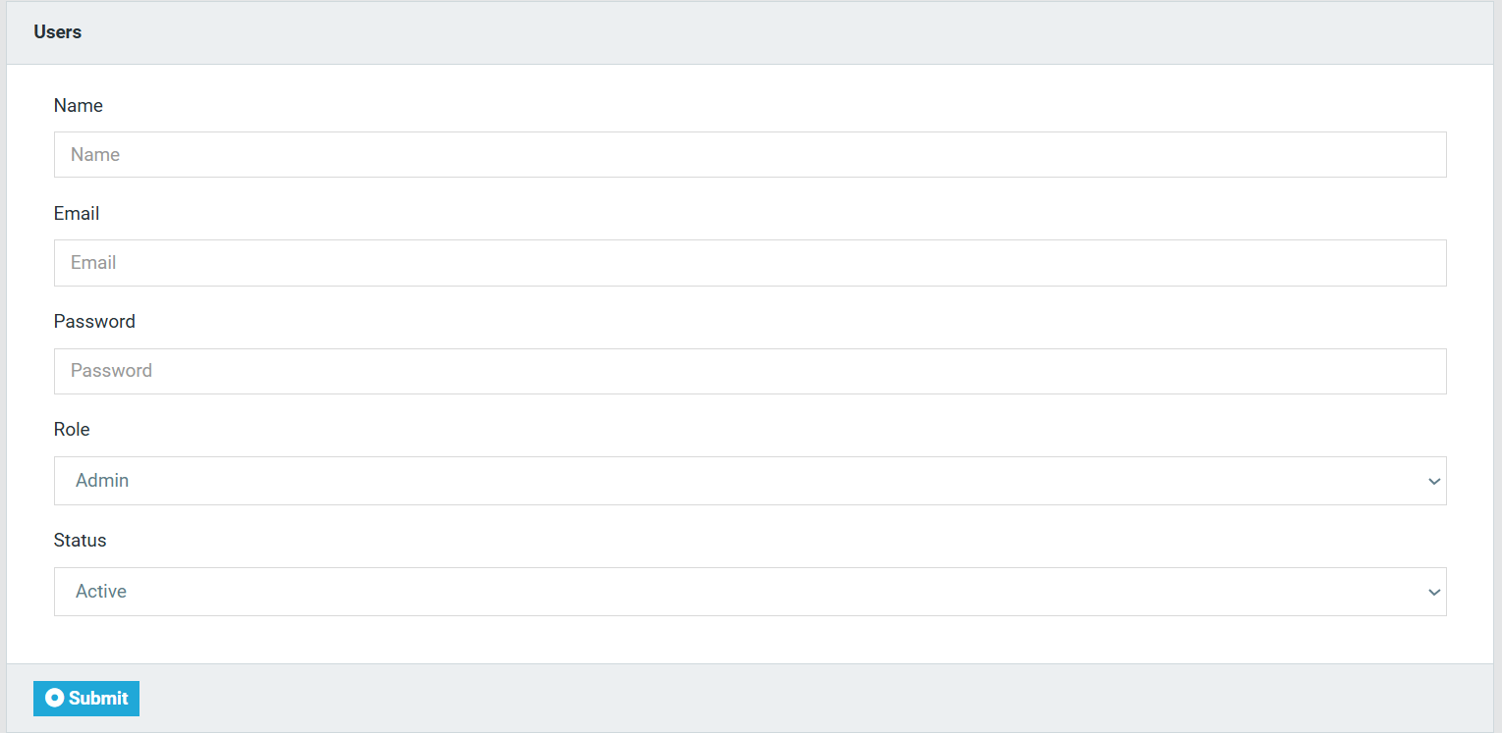

### Settings

**Club Settings: This section allows administrators to modify essential details about the club, such as the club’s name, description, location, operating hours, and social media links. These settings ensure that the website reflects the most current and accurate information.**

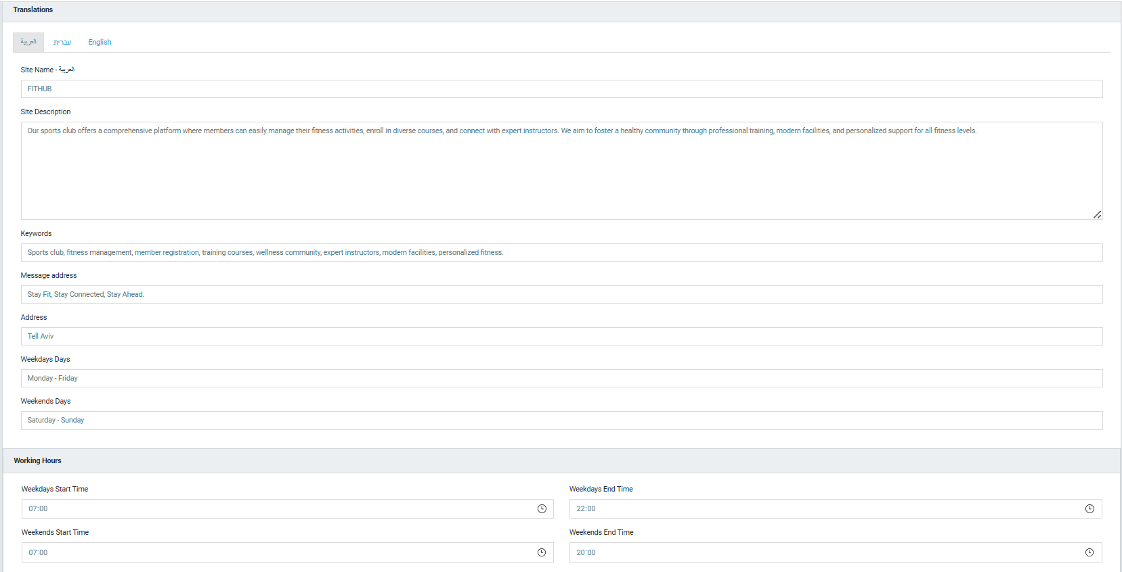

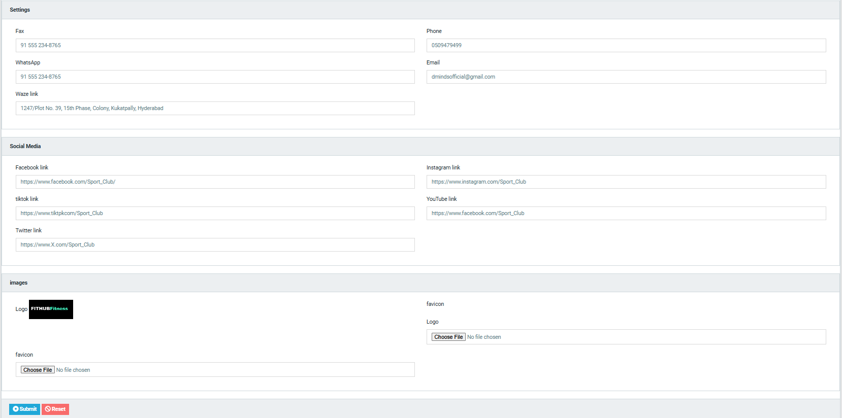

### Payment

**Payment Management: This section provides a comprehensive overview of all payments made by members, including:Member NameCourse NameAmount Paid**

**Payment Type: The payment methods are categorized into:CashCredit CardBank Transfer**

**Payment Status:Paid: Full payment has been received.Partial: A partial payment has been made, typically relevant for cash payments.**

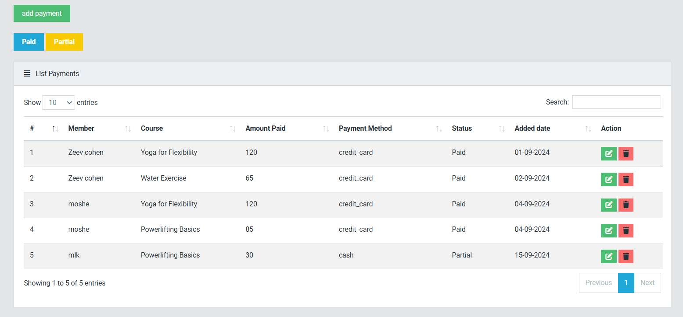

**Adding Payments: Administrators can manually add payments, including those made outside the online system (e.g., in-office cash payments). The system allows for partial payments, ensuring flexibility in managing member finances.**

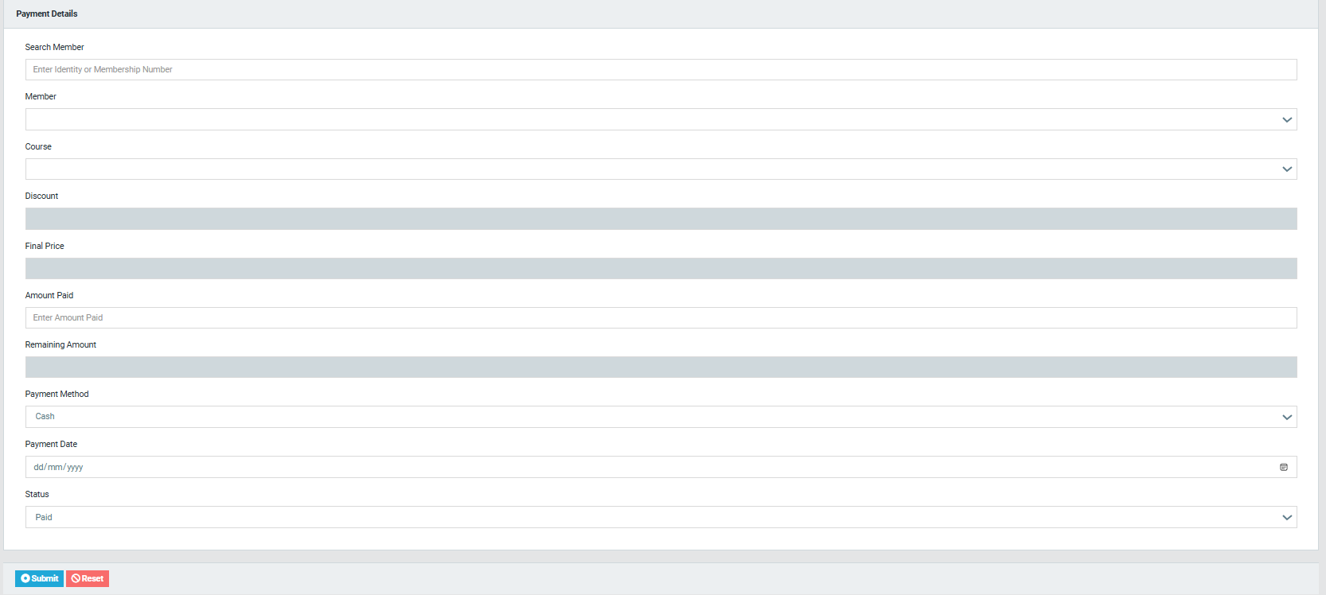

### Notes

**1. Sidebar Visibility**

**The sidebar is a constant element throughout the website, remaining visible after every action to ensure seamless navigation. However, in the provided images, the sidebar is not displayed as the images have been cropped for clarity and focus on specific content.**

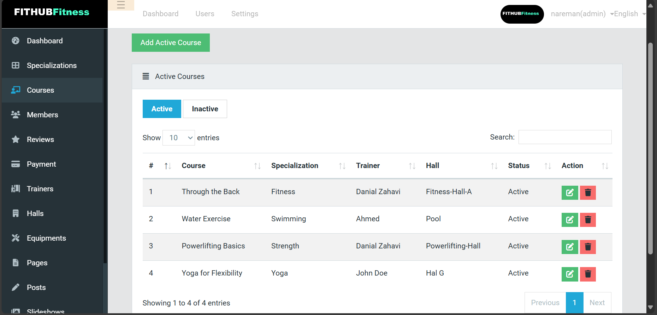

**2. Multilingual Support**

**The website supports three languages: Arabic, Hebrew, and English. For much of the content creation process, a translation field appears with the corresponding sections in each of the three languages. For example, when adding a new course, if you wish for it to be available in all three languages, you must fill out the details in each language. However, if you prefer to provide the information only in English, you have the option to do so without completing the other language fields.:**

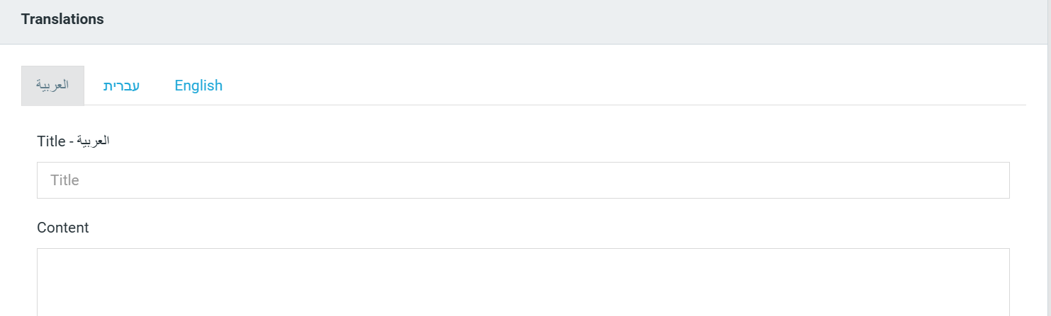



# Maintenance Guide

## Technology Summary:

Backend: PHP (Laravel 9)

Frontend: HTML, CSS (Bootstrap), JavaScript (jQuery)

Database: MySQL

Template Engine: Blade

Libraries: DataTables, Laravel Localization

Development Tools:

VS Code

Composer

Node.js and npm

Local server

## Technical Details:

1. Backend (PHP Laravel 9)

Laravel Usage: Laravel is used as a robust framework for managing data and server processes via the MVC (Model-View-Controller) architecture. This includes handling databases, processing requests, managing authentication, and other functionalities.

2. Frontend (HTML, CSS, JavaScript)

HTML: Used for structuring content and displaying data.

CSS (Bootstrap): Used for designing a responsive and attractive user interface. Bootstrap offers ready-made components and flexible layouts that help in developing user interfaces efficiently.

JavaScript (jQuery): Enhances interactivity on the frontend by handling events and updating elements without reloading the page.

3. Database (MySQL)

MySQL: A relational database used to store and manage data like users, events, and courses. Laravel manages database interactions through the Eloquent ORM.

4. Template Engine (Blade)

Blade: Utilized for creating dynamic HTML templates by embedding data from Laravel, allowing for reusable interfaces and efficient management of display logic.

5. Libraries

DataTables: Used for enhancing the display of data in tables with features such as filtering, searching, and interactive sorting.

Laravel Localization: Provides translation and localization support, enabling the application to present a multilingual interface to cater to users from different linguistic backgrounds.

6. Development Tools

VS Code: The main code editor used for writing and modifying the code.

Composer: Manages the libraries and dependencies needed by the application.

Node.js and npm: Used for managing frontend dependencies.

## Applying the Technologies in the Project:

Laravel: Manages the database, processes frontend requests, handles authentication and registration, and executes backend logic.

HTML & CSS (Bootstrap): Designs and structures the user interface for the control panel and the website.

JavaScript (jQuery): Improves frontend interactivity.

MySQL: Stores and organizes data efficiently.

Blade: Creates dynamic HTML templates displaying data from Laravel.

DataTables: Displays data in interactive tables with sorting and searching features.

Laravel Localization: Manages translations and multilingual support.

VS Code: Primary code editor.

Composer: Manages libraries and dependencies.

Node.js and npm: Manages frontend dependencies.

Local Server: For running and developing the application.

## Project Development Environment Requirements:

Operating System: Windows

Web Server: XAMPP (version 8.0 or higher)

Database Engine: MySQL

Programming Framework: PHP (Laravel 9)

PHP Version: 8.1 or higher

Development Environment: Visual Studio Code

Dependency Management: Composer

Setting Up the Sports Club Management System Development Environment

This section outlines all the necessary steps to set up the development environment, ensuring smooth operation and development of the system. Key steps include:

1. Installing the Programming Language - PHP

PHP version 8.1 or higher is required, as the project depends on Laravel 9.

You can download PHP from sources like XAMPP (which also includes Apache and MySQL) or install it separately.

Download link: https://www.php.net/downloads.

2. Using Composer, PHP’s Dependency Manager:



3. Installing the Database - MySQL

The project relies on MySQL to store and manage data.

MySQL is installed as part of XAMPP or can be installed separately.

Download link: <https://dev.mysql.com/downloads/>.

Create a new database for the project and update the connection in the .env file in Laravel:

DB_CONNECTION=mysql

DB_HOST=127.0.0.1

DB_PORT=3306

DB_DATABASE=newalmrkz_fithub

DB_USERNAME=newalmrkz_fithub

DB_PASSWORD=fithub#nare#2024

4. Installing Node.js and npm

Node.js and npm are required to manage frontend dependencies (CSS, JavaScript).

Download link: <https://nodejs.org>

After installation, run the following commands in the project directory to install all necessary dependencies:

-npm install

To run the frontend files during development, execute:

-npm run dev

5. Installing Project Libraries and Dependencies

During development, the system relies on some additional libraries and dependencies:

Bootstrap: For styling the user interface (CSS).

DataTables: To manage dynamic tables with features like search, sorting, and data display.

Laravel Localization: To manage translations and multi-language support.

6. Version Control System - Git

It is essential to install and set up a version control system like Git to manage the code.

After installation, you can initialize a Git repository for the project:

-git init

7. Setting Up Environment Variables

For complex projects, you may need to set up environment variables like API keys or database connection details.

These variables can be configured in the project’s .env file.

8. Cloud Connectivity (Optional)

If cloud storage or backend services are required, you can leverage platforms like Google Cloud or AWS.

For example, Firebase can be used to manage real-time databases or file storage.

## running the Sports Club Project on Another Device:

These are the complete steps to run the Sports Club project on a different device, detailing the requirements that must be installed on the machine before moving the project to the server directory.

1. Prerequisites

Before transferring and running the project, ensure that the following tools are installed on the device:

XAMPP or WAMP: To set up the local server with Apache and MySQL.

Composer: To manage Laravel dependencies.

Node.js: To install and manage frontend dependencies (JavaScript and CSS).

2. Transfer the Project and Run It

2.1. Move the project folder (sport_club) to the following path (in case of XAMPP):

C:\xampp\htdocs

Start XAMPP

2.2. :Open XAMPP and start both Apache and MySQL.

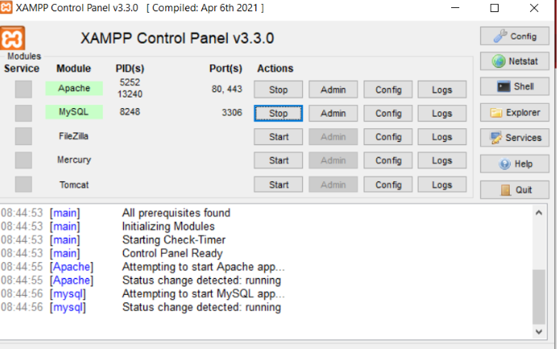

3.Create the database in phpMyAdmin:

Open the browser and navigate to phpMyAdmin using this link:

-http://localhost/phpmyadmin

4. Create a new database named sport_club or any name of your choice.

5. After creating the database, import the SQL file that contains the project tables.

- Select the database you created.

- Click Import and select the SQL file for the tables.

- Click Go to import the tables.

Update the .env File

6. Open the project’s .env file in a code editor and update the database connection settings accordingly.

7. Run Composer and npm Commands

Open a terminal or command prompt inside the project folder and run the following commands:

composer install

npm install

npm run dev

8. Start the Server

Run the Laravel server using the following command:

php artisan serve

You can access the project at:

http://localhost:8000

9. Test the project:

Ensure that all project features are working properly, including:

- Connecting to the database.

- Logging in users.

- Viewing and managing courses and users.

# .Tests:

## Unit Tests:

### Registration

|  |  |  |
| --- | --- | --- |
| Registration | | |
| Number | **Test Subject** | **Expected Result** |
| 1 | Enter a username that already exists in the system | System Displays:  “The username already exists, try another” |
| 2 | Enter a short password | System Displays:  “The password is too short, please enter at least 8 characters” |
| 3 | Enter an email that already exists in the system | System Displays:  “The email address is already being used” |
| 4 | Enter an invalid email address | System Displays:  “Invalid email address” |
| 5 | According to the date of birth entered the user is under the age of 16 | System Displays:  “The use of the application is only allowed from the age of 16 and above” |
| 6 | There is an empty field | System Displays:  “Please fill in all required fields” |
| 7 | The registration has been completed | The system switches to the home page screen |

### Login:

|  |  |  |
| --- | --- | --- |
| Login | | |
| Number | **Test Subject** | **Expected Result** |
| 1 | There is an empty field | System Displays:  “Please fill all required fields” |
| 2 | Enter a password shorter than 8 characters | System Displays:  “The password invalid” |
| 3 | Enter a username that doesn’t exist in DB | System Displays:  “Username or Password is incorrect” |
| 4 | Enter an incorrect password | System Displays:  “Username or Password is incorrect” |
| 5 | Successful login | System switches to user home page screen |

### Course Registration:

|  |  |  |
| --- | --- | --- |
| Course Registration | | |
| Number | **Test Subject** | **Expected Result** |
| 1 | |  | | --- | | Enter invalid payment details |  |  | | --- | |  | | System Displays:  "Payment failed: Invalid payment details" |
| 2 | Attempt to register without being logged in | System Displays:  "Please log in to register for the course" |
| 3 | Register for a full course | System Displays:  "Registration failed: Course is full"   |  | | --- | |  | |
| 4 | Register with missing fields | System Displays:  "XXXX is required" |
|  |  |  |

### Course Creation (Admin):

|  |  |  |
| --- | --- | --- |
| Course Creation (Admin) | | |
| Number | **Test Subject** | **Expected Result** |
| 1 | |  | | --- | | Enter invalid course dates |  |  | | --- | |  | | System Displays:  "Start date must be before the end date" |
| 2 | |  | | --- | | Enter an empty course name |  |  | | --- | |  | | System Displays:  "Course name is required" |
| 3 | |  | | --- | | Set negative course duration |  |  | | --- | |  | | System Displays:  "Duration must be a positive number" |

### Messaging System:

|  |  |  |
| --- | --- | --- |
| Messaging System | | |
| Number | **Test Subject** | **Expected Result** |
| 1 | |  | | --- | | Send a message with an empty content |  |  | | --- | |  | | System Displays:  "Message content cannot be empty" |
| 2 | |  | | --- | | Successfully send a message |  |  | | --- | |  | | System Displays:  "Message sent successfully!" |

## Manual testing

|  |  |  |
| --- | --- | --- |
| **Test Case** | **Steps** | **Expected Results** |
| Navigation from the login screen to the main screen after successful login | Open the application, enter valid login credentials, and click on the 'login' button | The application should navigate to the main screen |
| Navigate from the main screen to the Profile screen using the navigation bar. | On the main screen, click on the 'Profile' tab in the navigation bar | The application should navigate to the Profile screen |
| Updating User Profile Information | Access the Profile screen, edit user profile information (e.g., name, email, phone number), and save the changes. | The updated user profile information should be successfully saved and reflected in the system. |
| Navigation from the main screen to a specific course | Click on a course from the section courses | The application should navigate to the specific course screen and display comprehensive information about the selected course |
| Viewing Registered Courses | Access the user's profile (dashboard) and navigate to the section displaying registered courses. | The application should display a list of courses that the user has successfully registered for. |
| Logging Out | From any screen, log out of the application. | The application should successfully log the user out. |

# . Results & Conclusion:

The development of the Sports Club Management System has successfully met my goals, resulting in an intuitive and efficient platform for managing club activities, courses, and member interactions. By integrating modern web technologies such as PHP (Laravel), MySQL, Bootstrap, and JavaScript (jQuery, Axios), I have created a system that is both robust and user-friendly. The project involved substantial research and feedback from club managers, members, and instructors, helping me design a solution that addresses key pain points such as course management, scheduling, and member communications.

One of the significant achievements of this project is the seamless integration of dual interfaces—one for club managers and another for members. This dual interface ensures that the system meets the different needs of each user group, whether it’s administrative tasks or member activity tracking. Challenges related to data security, scalability, and user adoption were effectively managed, resulting in a platform that is both secure and scalable for future growth.

To ensure the reliability and functionality of the system, I personally conducted rigorous testing. This involved checking each feature, from course registration to real-time messaging, to ensure that the platform performs optimally without any errors or usability issues. These tests confirmed that the system is not only reliable but also easy to navigate, offering a smooth user experience.

In conclusion, the Sports Club Management System has succeeded in streamlining club operations while offering members an engaging and accessible platform. It not only simplifies administrative tasks for club managers but also provides members with an enriched experience by enabling them to register for courses, communicate with instructors, and track their progress. The system’s scalability and robust architecture ensure its ability to handle growing user demands, making it a long-term solution for sports clubs.

# . References

[1] <https://w3techs.com/technologies/details/pl-php>

[2] <https://www.jetbrains.com/lp/devecosystem-2023/>

[3] <https://db-engines.com/en/ranking>

[4] <https://www.php.net/manual/en/intro-whatcando.php>

[5] <https://dev.mysql.com/doc/refman/8.0/en/scalability.html>

GitHub repository:

[6] <https://github.com/AhmedMahamidVi7/Sports-Club-Management-System>